ROASTED SPATCHCOCK CHICKEN  COOK TIME: 30-45 mins  SOURCE: Unknown  #chicken #American #roast | 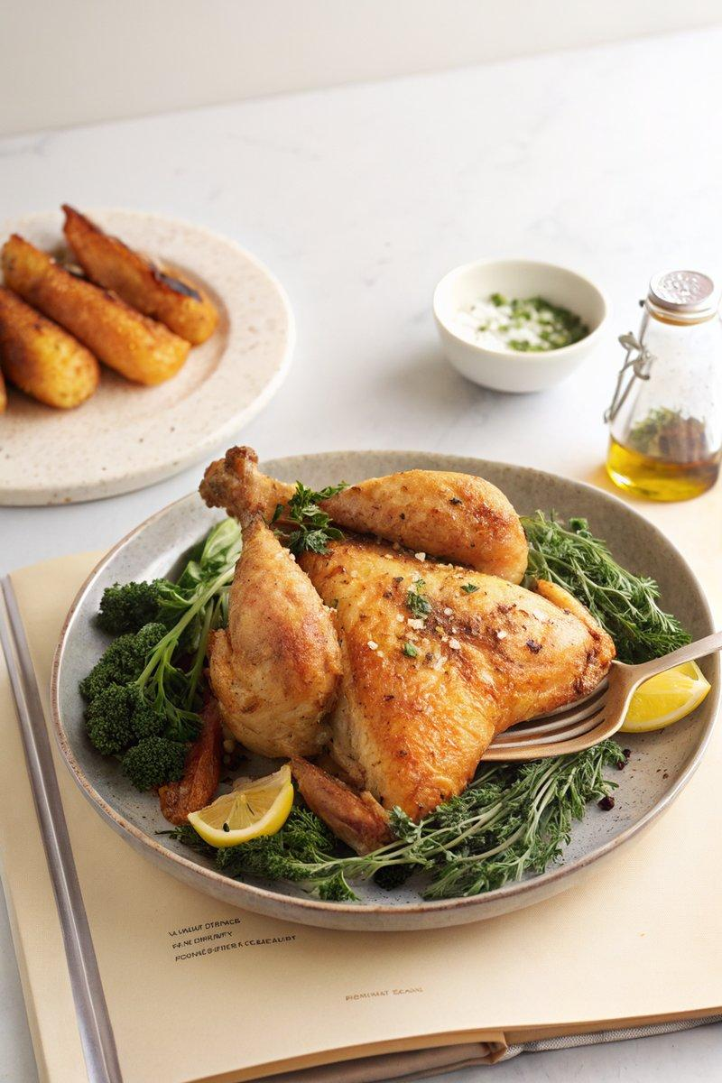

INGREDIENTS  - {'group': 'Main', 'item': '1 whole chicken, ~1.5kg'}  - {'group': 'Seasoning', 'item': 'Kosher salt'}  - {'group': 'Seasoning', 'item': 'Freshly cracked black pepper'}  - {'group': 'Seasoning', 'item': 'Seasonings of choice'}  - {'group': 'Main', 'item': 'Neutral tasting oil'} | PREP  Spatchcock the chicken by removing the backbone with kitchen shears. Flatten the bird by pressing down on the breastbone. Pat the chicken dry and season generously with salt, pepper, and any additional seasonings. Place the chicken skin-side up on a wire rack over a foil-lined baking sheet and refrigerate uncovered for 24 hours.  COOK  Preheat the oven to 230°C (450°F (230°C)). Remove the chicken from the refrigerator and let it rest at room temperature for 30 minutes. Lightly coat the chicken with neutral oil. Roast the chicken on the wire rack for 30 to 45 minutes, checking the breast meat after 25 minutes. If the breast meat reaches 70°C (158°F (70°C)), remove it from the oven and continue cooking the legs until they are crispy and reach 70°C (158°F (70°C)).  PLATING  Let the chicken rest uncovered for 8 minutes before carving. Serve with fresh herbs for garnish.

NOTES:
To make a gravy, deglaze the baking sheet with 250ml boiling water. In a pot, melt 14g butter, add 9g all-purpose flour, and stir until bubbly. Add the deglazing mixture and cook until thickened.

