CLASSIC BEEF POT ROAST WITH GRAVY  COOK TIME: 3 hrs  SOURCE: Unknown  #beef #American #braise | 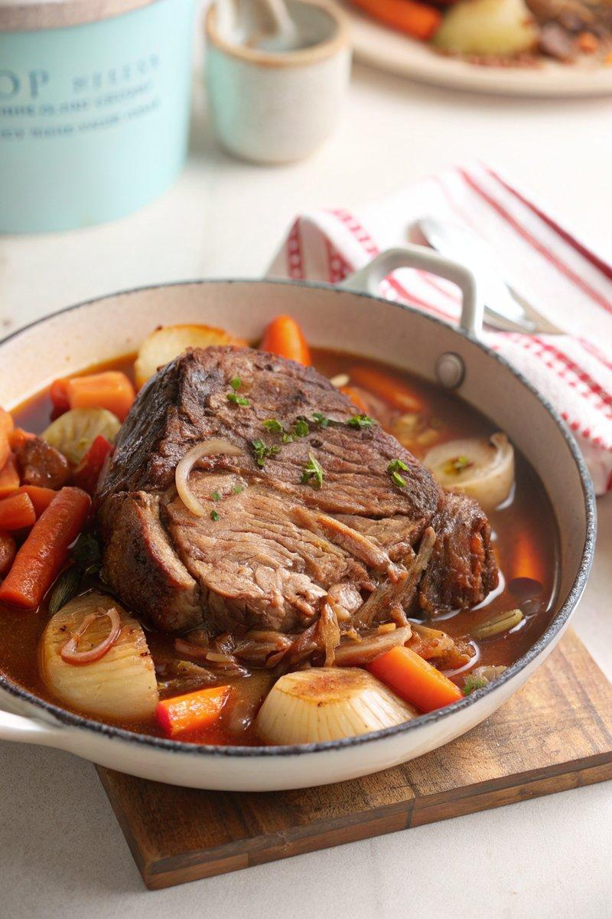

INGREDIENTS  - {'group': 'Main', 'item': '1.5kg beef chuck roast'}  - {'group': 'Main', 'item': '2 tbsp olive oil'}  - {'group': 'Main', 'item': '1 large onion, sliced'}  - {'group': 'Main', 'item': '3 garlic cloves, minced'}  - {'group': 'Main', 'item': '4 medium carrots, cut into chunks'}  - {'group': 'Main', 'item': '3 sprigs fresh thyme'}  - {'group': 'Main', 'item': '750ml beef stock'}  - {'group': 'Seasoning', 'item': 'Salt and freshly cracked black pepper'}  - {'group': 'Gravy', 'item': '75g unsalted butter'}  - {'group': 'Gravy', 'item': '75g all-purpose flour'} | PREP  Preheat the oven to 170°C (340°F (171°C)). Season the beef chuck roast generously with salt and pepper.  COOK  Heat olive oil in a Dutch oven over medium-high heat. Sear the beef on all sides until browned, about 2-3 mins per side. Remove the beef and set aside. In the same pot, add onion and garlic, sauté until the onion softens. Pour in the beef stock and bring to a simmer. Return the beef to the pot, add thyme sprigs, cover, and transfer to the oven. Braise for 1.5 hrs, then add carrots around the beef. Continue cooking for another 1.5 hrs until the beef is tender.  PLATING  Transfer the beef and vegetables to a serving platter and cover with foil to keep warm. Discard thyme sprigs. Reserve 750ml of the cooking liquid for the gravy.

NOTES:
To make the gravy, melt butter in a saucepan over medium heat. Whisk in flour and cook for 45 seconds. Gradually add the reserved cooking liquid, whisking until smooth and thickened. Serve the roast and vegetables with the gravy.

