JAPANESE BRAISED PORK BELLY  COOK TIME: 2 hrs 20 mins  SOURCE: Unknown  #pork #Asian #braise | 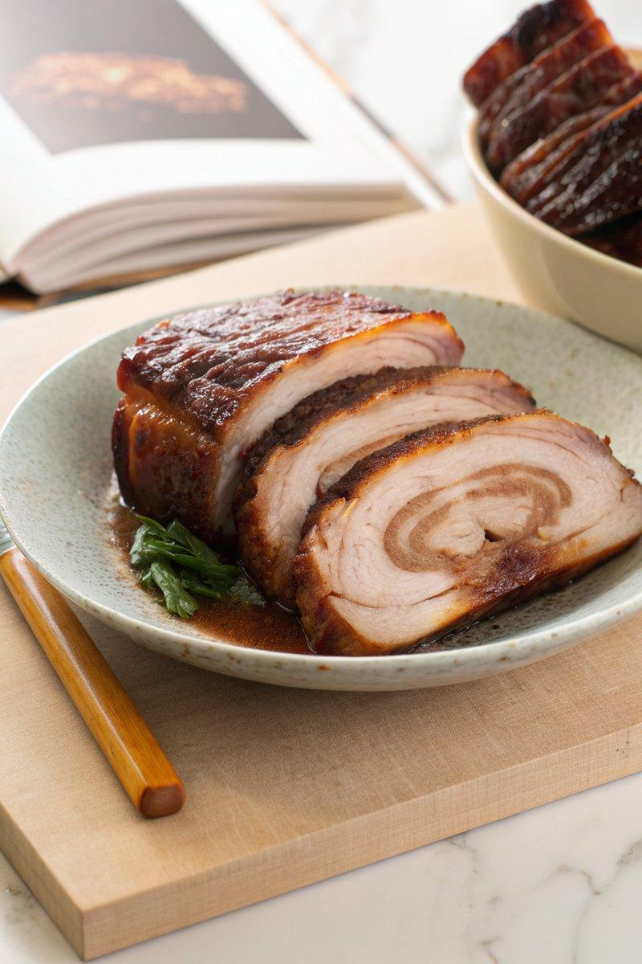

INGREDIENTS  - {'group': 'Main', 'item': '1.5kg pork belly, skin removed'}  - {'group': 'Sauce', 'item': '175ml soy sauce'}  - {'group': 'Sauce', 'item': '250ml mirin'}  - {'group': 'Sauce', 'item': '250ml sake'}  - {'group': 'Sauce', 'item': '100g granulated sugar'}  - {'group': 'Main', 'item': '2 tbsp neutral oil'}  - {'group': 'Main', 'item': '5cm piece fresh ginger, peeled and roughly chopped'}  - {'group': 'Main', 'item': '1 bunch green onions, cut into 5cm segments'}  - {'group': 'Main', 'item': '1 shallot, peeled and halved'} | PREP  Lay the pork belly flat and roll it tightly into a log from the longest side. Secure with kitchen twine every few inches.  COOK  Heat oil in a Dutch oven over medium-high heat. Sear the rolled pork belly for 2-3 mins on each side until browned. Remove and set aside. In a bowl, mix soy sauce, mirin, sake, sugar, and water. Pour into the Dutch oven, bring to a boil, and deglaze the pan. Reduce heat to low, add the pork, ginger, green onions, and shallot. Cover and braise in the oven, turning every 15 mins for 1-2 hrs until tender.  PLATING  Remove pork from the Dutch oven and let cool. Slice and sear before serving. Store in an airtight container in the fridge for up to 10 days.

NOTES:
Marinate the pork overnight in the cooking liquid for enhanced flavour. Ideal for ramen or as a sandwich filling.

