CRISPY CHICKEN NUGGETS  COOK TIME: 25 mins  SOURCE: Unknown  #chicken #American #deep-fry | 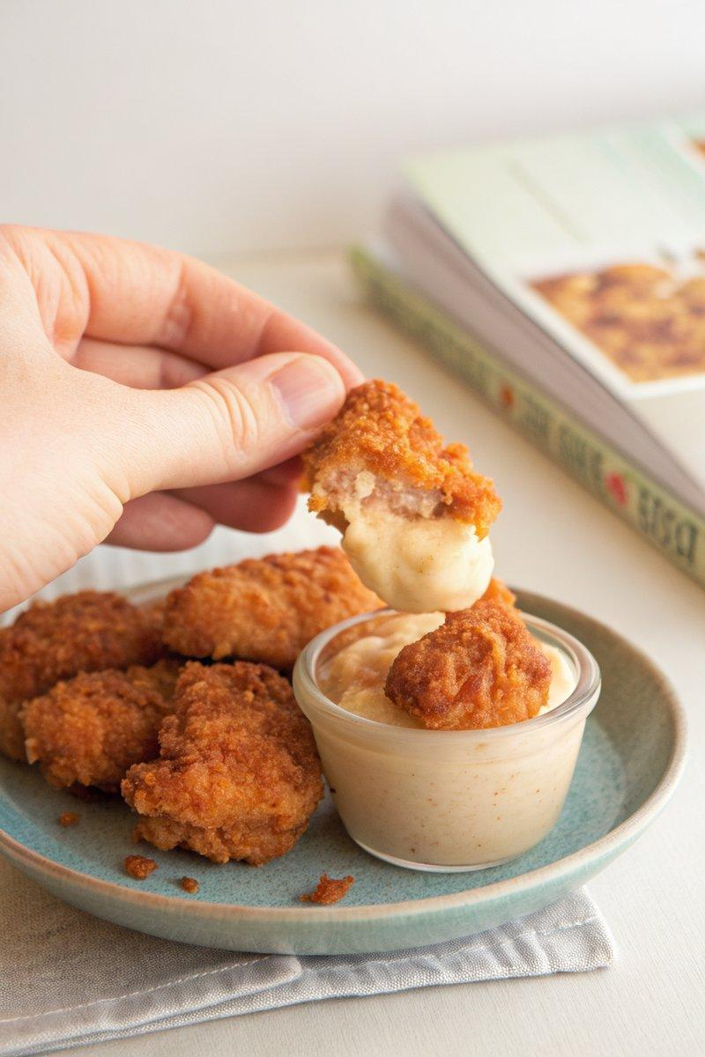

INGREDIENTS  - {'group': 'Main', 'item': '500g chicken thighs, cut into 1-inch pieces'}  - {'group': 'Marinade', 'item': '250ml buttermilk'}  - {'group': 'Dredge', 'item': '300g all-purpose flour'}  - {'group': 'Dredge', 'item': '1 tbsp smoked paprika'}  - {'group': 'Dredge', 'item': '1 tsp ground oregano'}  - {'group': 'Dredge', 'item': '1 tsp garlic powder'}  - {'group': 'Dredge', 'item': '1 tbsp kosher salt'}  - {'group': 'For Frying', 'item': 'Vegetable oil'} | PREP  Cut the chicken thighs into 1-inch (3cm (1-inch)) pieces. In a bowl, combine the chicken pieces with buttermilk and salt, ensuring they are well coated. Cover and refrigerate for at least 1 hour or overnight.  COOK  Heat vegetable oil in a deep cast-iron skillet to 180°C (350°F (175°C)). In a separate bowl, mix flour, smoked paprika, oregano, garlic powder, and salt. Remove chicken from marinade, dredge in the flour mixture, pressing to adhere. Fry in batches for 4-6 mins until golden brown and cooked through. Maintain oil temperature by adjusting heat as needed.  PLATING  Transfer fried chicken to a wire rack to drain excess oil. Serve hot with your choice of dipping sauces.

NOTES:
Ensure the oil temperature is consistent for even cooking. Serve with sauces like garlic mayo, ranch, or barbecue for added flavour.

