BASIL PESTO GNOCCHI  COOK TIME: 1 min  SOURCE: Unknown  #gnocchi #Italian #boil | 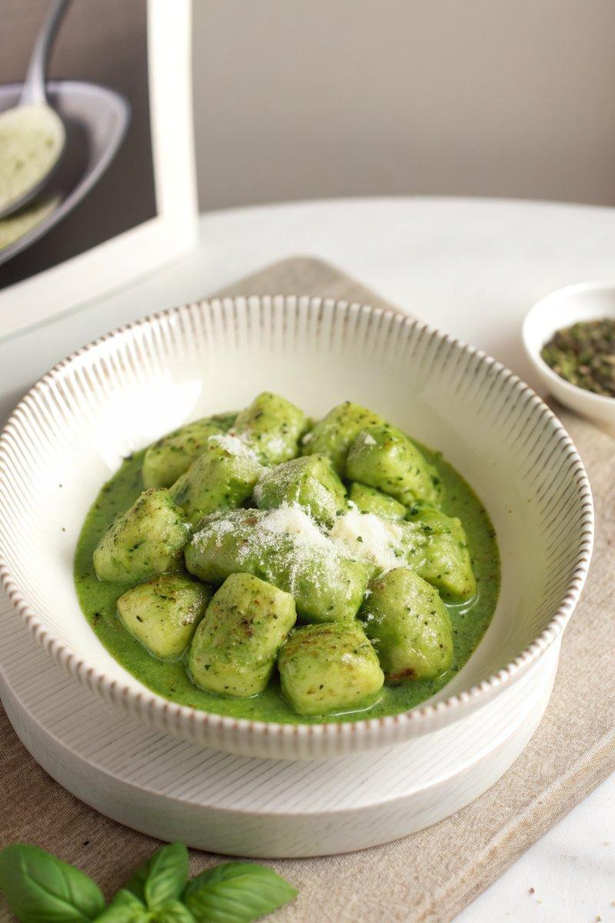

INGREDIENTS  - {'group': 'Main', 'item': '1 batch uncooked potato gnocchi'}  - {'group': 'Sauce', 'item': '1 batch pesto sauce'}  - {'group': 'Garnish', 'item': 'Freshly grated Parmigiano-Reggiano cheese'}  - {'group': 'Seasoning', 'item': 'Kosher salt'}  - {'group': 'Seasoning', 'item': 'Freshly cracked black pepper'} | PREP  Prepare a batch of pesto sauce if not already made. Grate the Parmigiano-Reggiano cheese and set aside.  COOK  Fill a large pot three-quarters full with water and season generously with salt until it tastes like the ocean. Bring to a boil. Add the gnocchi and cook until they float to the surface, about 1 minute. Remove the gnocchi with a slotted spoon and transfer to a bowl. Add the pesto sauce and a splash of the cooking water, tossing to coat the gnocchi evenly. Adjust seasoning with salt and freshly cracked black pepper.  PLATING  Divide the gnocchi among serving bowls. Top each with a generous amount of freshly grated Parmigiano-Reggiano and a sprinkle of black pepper. Serve immediately.

NOTES:
For best results, use fresh potato gnocchi and high-quality Parmigiano-Reggiano. Adjust the amount of pesto to taste.

