CLASSIC SPAGHETTI CARBONARA  COOK TIME: 15 mins  SOURCE: Unknown  #pasta #Italian #stovetop | 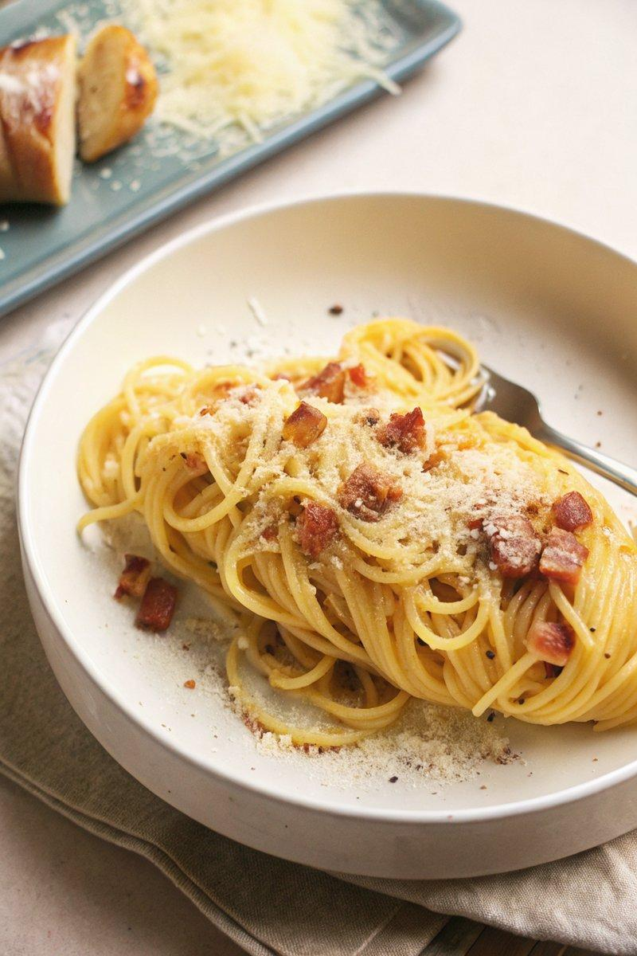

INGREDIENTS  - {'group': 'Main', 'item': '450g uncooked spaghetti'}  - {'group': 'Main', 'item': '110g guanciale, pancetta, or bacon, diced into 1.25 cm cubes'}  - {'group': 'Main', 'item': '2 cloves garlic, roughly chopped'}  - {'group': 'Main', 'item': '5-6 large egg yolks'}  - {'group': 'Main', 'item': '240ml reserved pasta water'}  - {'group': 'Cheese', 'item': '150g freshly grated Parmigiano-Reggiano or Grana Padano cheese'}  - {'group': 'Cheese', 'item': '118g freshly grated Pecorino Romano cheese'}  - {'group': 'Seasoning', 'item': 'Kosher salt and freshly cracked black pepper, to taste'} | PREP  Dice the guanciale into 1.25 cm cubes and roughly chop the garlic. Grate the cheeses and separate the egg yolks.  COOK  Bring a large pot of salted water to a boil and cook the spaghetti until al dente, about 4 mins for fresh pasta or 12 mins for dried. Reserve 240ml of pasta water and drain the pasta. In a cold skillet, add the guanciale and cook over medium-low heat until crispy and the fat has rendered. Remove from heat and stir in the garlic. Add the drained pasta to the skillet, tossing to coat in the rendered fat. Off the heat, add the egg yolks, Parmigiano-Reggiano, and Pecorino Romano. Toss vigorously, adding reserved pasta water a little at a time, until a glossy sauce forms.  PLATING  Serve immediately, topping with additional Parmigiano-Reggiano and freshly cracked black pepper.

NOTES:
Ensure the skillet is not too hot when adding the egg yolks to prevent scrambling. Adjust seasoning with salt and pepper to taste.

