CLASSIC CACIO E PEPE PASTA  COOK TIME: 15 mins  SOURCE: Unknown  #pasta #italian #stovetop | 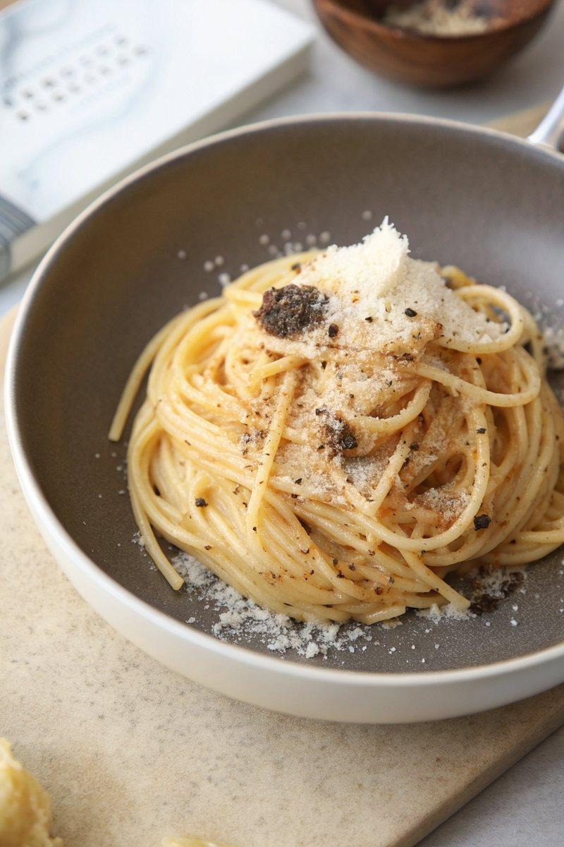

INGREDIENTS  - {'group': 'Main', 'item': '225g bucatini or spaghetti'}  - {'group': 'Seasoning', 'item': 'Kosher salt, to taste'}  - {'group': 'Sauce', 'item': '30ml extra virgin olive oil'}  - {'group': 'Sauce', 'item': '6g freshly cracked black pepper'}  - {'group': 'Sauce', 'item': '120g freshly grated Parmigiano-Reggiano cheese'}  - {'group': 'Sauce', 'item': '120g freshly grated Pecorino Romano cheese'}  - {'group': 'Garnish', 'item': 'Freshly shaved black truffle (optional)'} | PREP  Grate the Parmigiano-Reggiano and Pecorino Romano cheeses. Crack the black pepper coarsely.  COOK  Bring a large pot of salted water to a boil. Cook the pasta until just under al dente, about 1 minute for fresh pasta and 7 minutes for dried. Reserve 350ml of pasta water and drain the pasta. In a saucepan, heat olive oil over medium heat, add black pepper, and toast for 30 seconds. Add 250ml of reserved pasta water and bring to a simmer. Add the pasta and cook for 3-5 minutes until the liquid reduces by 75%. Stir in the cheeses until melted and a creamy sauce forms.  PLATING  Transfer the pasta to a serving bowl. Garnish with additional Parmigiano-Reggiano and freshly shaved black truffle, if using. Serve immediately.

NOTES:
Ensure the pasta water is well-salted to enhance the flavor of the dish. Adjust the consistency of the sauce with additional pasta water if needed.

