CUBAN SANDWICH WITH MOJO PORK  COOK TIME: 35 mins  SOURCE: Unknown  #pork #Cuban #sandwich | 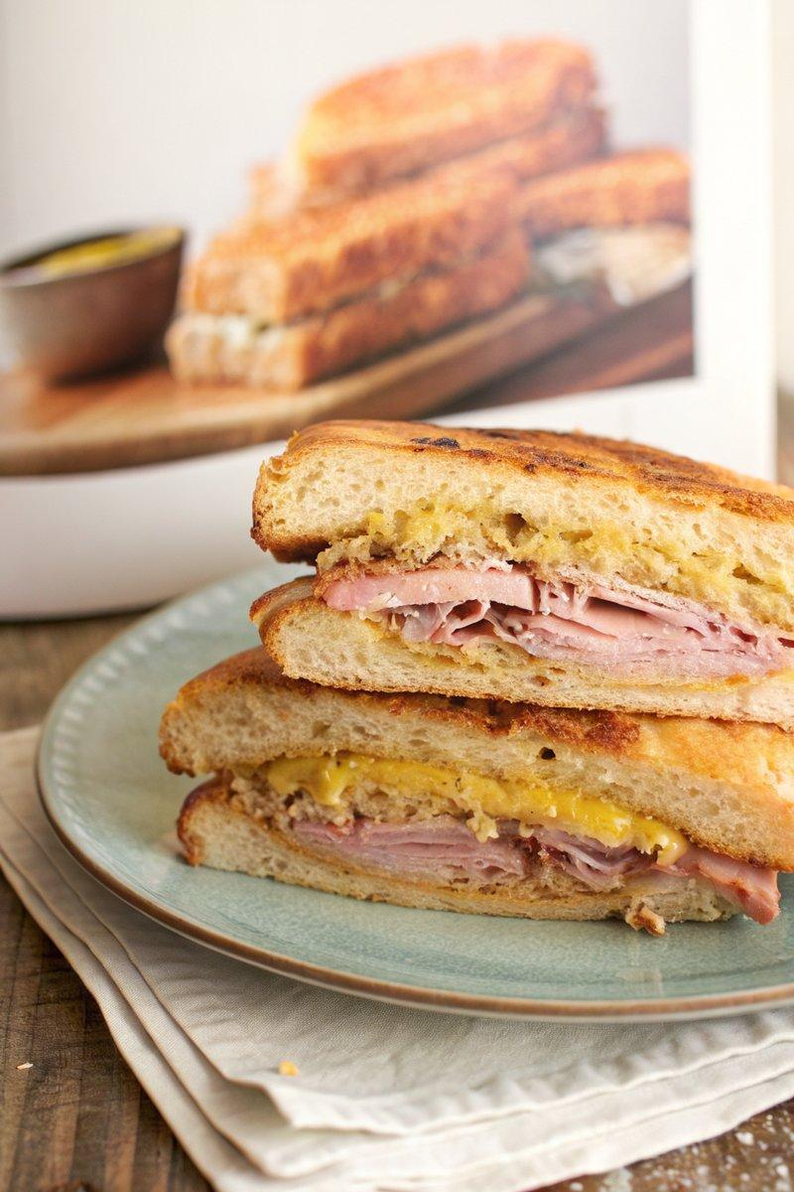

INGREDIENTS  - {'group': 'Main', 'item': '2 loaves Cubano bread, sliced to form 4 sandwiches'}  - {'group': 'Main', 'item': '1kg thin slices of boiled ham'}  - {'group': 'Main', 'item': '2-4 cups mojo-braised pulled pork'}  - {'group': 'Main', 'item': 'Slices of Swiss cheese'}  - {'group': 'Seasoning', 'item': 'Yellow mustard'}  - {'group': 'Main', 'item': '4-6 dill pickles, thinly sliced lengthwise'}  - {'group': 'Main', 'item': 'Unsalted butter, softened'} | PREP  Slice the Cubano bread to form 4 sandwiches. Thinly slice the dill pickles lengthwise.  COOK  Butter the inside of each bread slice. In a large cold pan, place the bread buttered-side down and toast over medium heat. In a separate pan, melt a little butter and sear the ham slices over medium-high heat until browned on both sides. Set aside. Once the bread is toasted, coat the inside with yellow mustard. Layer the pickles, seared ham, pulled pork, and Swiss cheese on the bottom slice. Top with the other bread slice. Preheat a cast-iron skillet. Butter the top and bottom of the sandwiches. In a medium pan, place the sandwiches and press with the cast-iron skillet. Toast until golden on both sides, flipping once.  PLATING  Cut each sandwich diagonally into two pieces and serve immediately.

NOTES:
For an extra touch, use a kitchen torch to start melting the cheese before assembling the sandwich.

