CLASSIC EGG DROP SOUP  COOK TIME: 20 mins  SOURCE: Unknown  #egg #asian #soup | 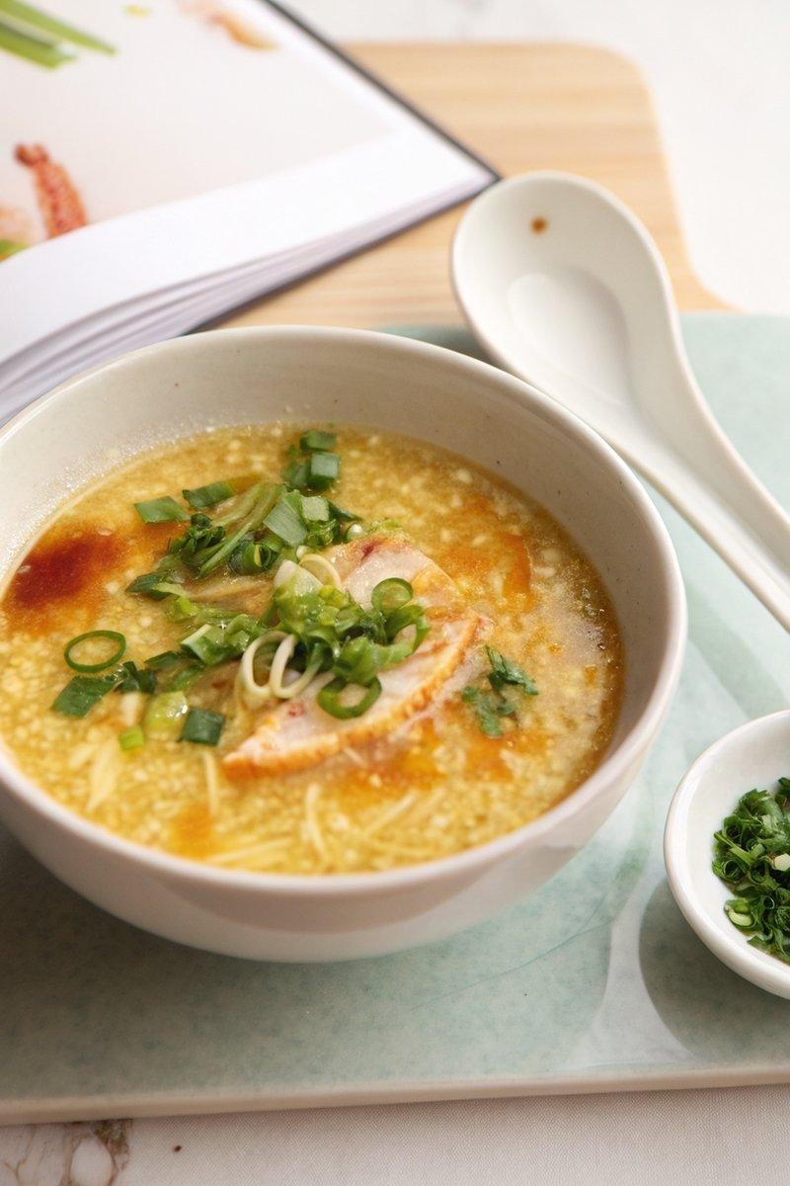

INGREDIENTS  - {'group': 'Main', 'item': '1L chicken stock'}  - {'group': 'Main', 'item': '2 large eggs, whisked'}  - {'group': 'Seasoning', 'item': '2 star anise'}  - {'group': 'Seasoning', 'item': '1 tsp coriander seeds'}  - {'group': 'Thickener', 'item': '2 tbsp cornstarch'}  - {'group': 'Thickener', 'item': '60ml water'}  - {'group': 'Sauce', 'item': '2 tbsp soy sauce'}  - {'group': 'Sauce', 'item': '1 tsp sesame oil'}  - {'group': 'Garnish', 'item': '2 tbsp chopped green onion'} | PREP  Whisk the eggs in a small bowl until smooth. In another bowl, mix the cornstarch with water to create a slurry. Place the star anise and coriander seeds in a piece of cheesecloth and tie it securely.  COOK  In a medium saucepan, bring the chicken stock to a boil over medium-high heat. Reduce to a simmer and add the cheesecloth with spices. Let it simmer for 10 minutes, then remove the spices. Stir in the cornstarch slurry and simmer until slightly thickened, about 1-2 minutes. While stirring the broth continuously, slowly drizzle in the whisked eggs to form ribbons. Turn off the heat and let the soup sit for 2 minutes to ensure the eggs are cooked through. Stir in the soy sauce and sesame oil.  PLATING  Ladle the soup into bowls and garnish with chopped green onion before serving.

NOTES:
For a more intense flavour, adjust the amount of soy sauce to taste. Serve immediately for the best texture.

