KEY LIME PIE WITH GRAHAM CRACKER CRUST  COOK TIME: 25 mins  SOURCE: Unknown  #lime #American #bake | 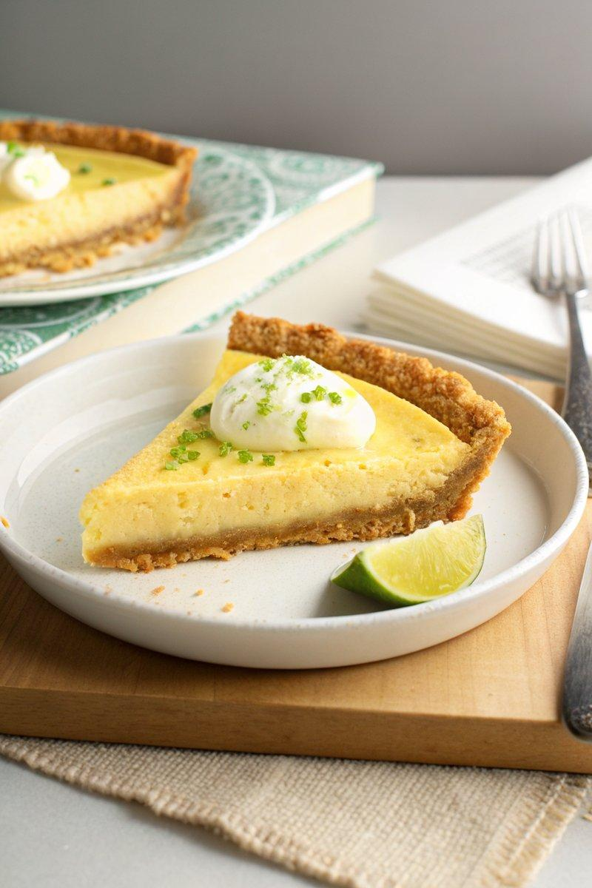

INGREDIENTS  - {'group': 'Crust', 'item': '250g graham crackers, crushed'}  - {'group': 'Crust', 'item': '72g unsalted butter, melted'}  - {'group': 'Crust', 'item': '3 tbsp dark brown sugar'}  - {'group': 'Crust', 'item': '1/4 tsp fine sea salt'}  - {'group': 'Filling', 'item': '4 large egg yolks'}  - {'group': 'Filling', 'item': '1 tbsp fresh key lime zest, plus extra for garnish'}  - {'group': 'Filling', 'item': '414ml sweetened condensed milk'}  - {'group': 'Filling', 'item': '125ml fresh key lime juice'}  - {'group': 'For Serving', 'item': 'Fresh whipped cream'} | PREP  Crush the graham crackers into fine crumbs using a resealable bag and a rolling pin. Melt the butter and set aside.  COOK  Preheat the oven to 180°C (350°F (175°C)). Combine the graham cracker crumbs, melted butter, brown sugar, and salt in a bowl, mixing until the texture resembles wet sand. Press the mixture firmly into a 23cm (9-inch) pie dish to form an even crust. Bake for 10 minutes, then allow to cool completely. In a medium bowl, whisk the egg yolks with the lime zest until smooth. Gradually whisk in the sweetened condensed milk and lime juice until fully combined. Pour the filling into the cooled crust and bake for 15-17 minutes, until the filling is mostly set but slightly jiggly in the center.  PLATING  Allow the pie to cool at room temperature, then refrigerate for at least 3 hours or overnight. Slice the chilled pie and serve with a dollop of whipped cream and a sprinkle of lime zest.

NOTES:
For a homemade sweetened condensed milk, simmer 875ml whole milk, 125ml heavy cream, and 200g sugar until reduced to 310ml.

