BANANA HOT FUDGE SUNDAE  COOK TIME: 3 mins  SOURCE: Unknown  #banana #American #no-cook | 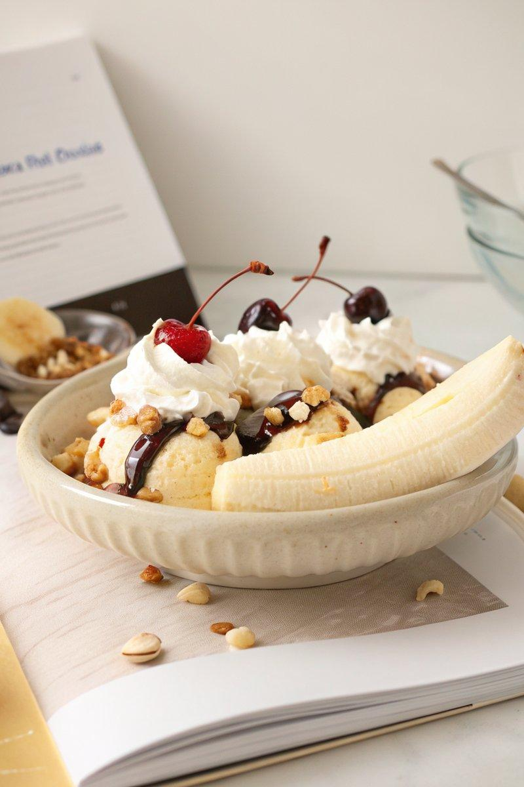

INGREDIENTS  - {'group': 'Main', 'item': '3 large scoops vanilla ice cream'}  - {'group': 'Main', 'item': '1 banana, halved lengthwise'}  - {'group': 'Garnish', 'item': '30g toasted hazelnuts, crushed'}  - {'group': 'Garnish', 'item': 'Fresh whipped cream'}  - {'group': 'Garnish', 'item': '10 Luxardo cherries'}  - {'group': 'Sauce', 'item': '500ml heavy whipping cream'}  - {'group': 'Sauce', 'item': '56g salted butter'}  - {'group': 'Sauce', 'item': '100g granulated sugar'}  - {'group': 'Sauce', 'item': '85g dark chocolate, finely chopped'}  - {'group': 'Sauce', 'item': '110g Dutch processed cocoa powder'}  - {'group': 'Sauce', 'item': '10ml pure vanilla extract'} | PREP  Halve the banana lengthwise and crush the toasted hazelnuts.  COOK  In a medium saucepan, combine heavy cream, butter, granulated sugar, and brown sugar. Bring to a light simmer over medium heat, whisking until melted and combined. Simmer for 1 minute, then whisk in dark chocolate until melted. Remove from heat, whisk in cocoa powder, and return to low heat, stirring for 30 seconds until thick and glossy. Remove from heat and whisk in vanilla extract. Strain if desired.  PLATING  In a long serving bowl, place vanilla ice cream scoops in the center. Arrange banana slices on either side. Drizzle with fudge sauce, sprinkle with hazelnuts, and add whipped cream. Top with cherries and serve immediately.

NOTES:
Store leftover fudge sauce in an airtight container in the refrigerator for up to 1 month. Reheat on the stovetop before using.

