CLASSIC CHOCOLATE CHIP COOKIES  COOK TIME: 13-15 mins  SOURCE: Unknown  #cookies #American #bake | 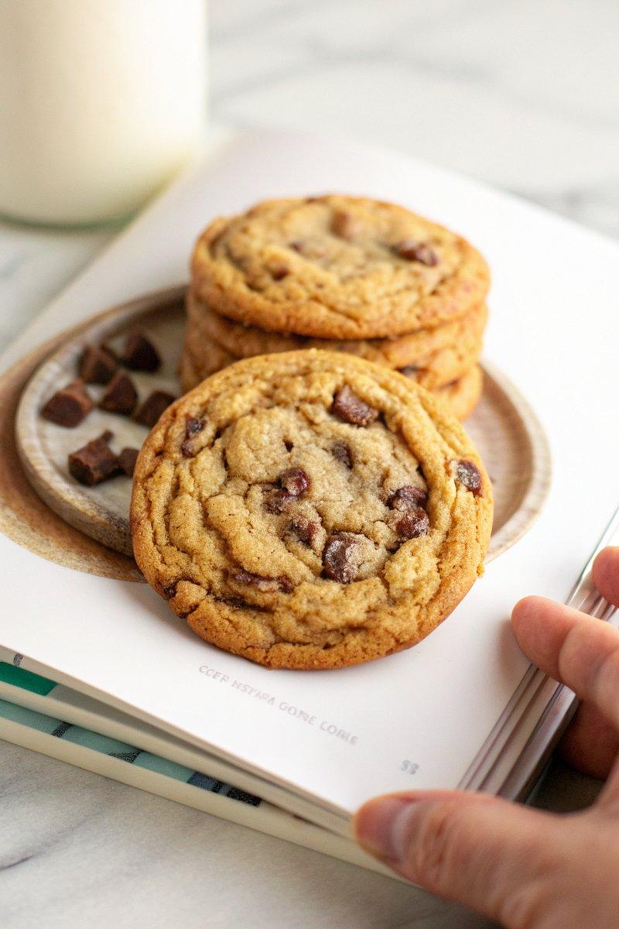

INGREDIENTS  - {'group': 'Main', 'item': '200g granulated sugar'}  - {'group': 'Main', 'item': '160g packed light brown sugar'}  - {'group': 'Main', 'item': '225g unsalted butter, melted'}  - {'group': 'Main', 'item': '1 large egg'}  - {'group': 'Main', 'item': '1 large egg yolk'}  - {'group': 'Main', 'item': '10ml pure vanilla extract'}  - {'group': 'Main', 'item': '197g unbleached all-purpose flour'}  - {'group': 'Main', 'item': '2g baking soda'}  - {'group': 'Main', 'item': '225g dark chocolate bar, roughly chopped'} | PREP  In a medium bowl, whisk together the granulated sugar, brown sugar, and salt. Slowly whisk in the melted butter until fully combined. Add the egg, egg yolk, and vanilla extract, mixing until smooth. In another bowl, combine the flour and baking soda. Gradually add the dry ingredients to the wet mixture, stirring until a dough forms. Fold in the chopped chocolate.  COOK  Preheat the oven to 180°C (350°F (175°C)) and line two baking sheets with parchment paper. If the dough was chilled overnight, let it sit at room temperature for 5-10 minutes until pliable. Using a medium ice cream scoop, place dough balls on the baking sheets, spaced 6.25cm (10-inch) apart. Bake one sheet at a time for 13-15 minutes, dropping the sheet onto the oven rack at 10, 7, and 3 minutes remaining to flatten the cookies slightly. Bake until the edges are golden and the centers are slightly underbaked.  PLATING  Allow the cookies to cool completely on a wire rack before serving. Store any leftovers in an airtight container at room temperature for up to one week.

NOTES:
For chewier cookies, ensure to drop the baking sheet during baking as described. Chilling the dough overnight enhances the flavour and texture.

