CLASSIC TIRAMISU WITH ZABAGLIONE CREAM  COOK TIME: Overnight to firm  SOURCE: Unknown  #dessert #Italian #no-cook | 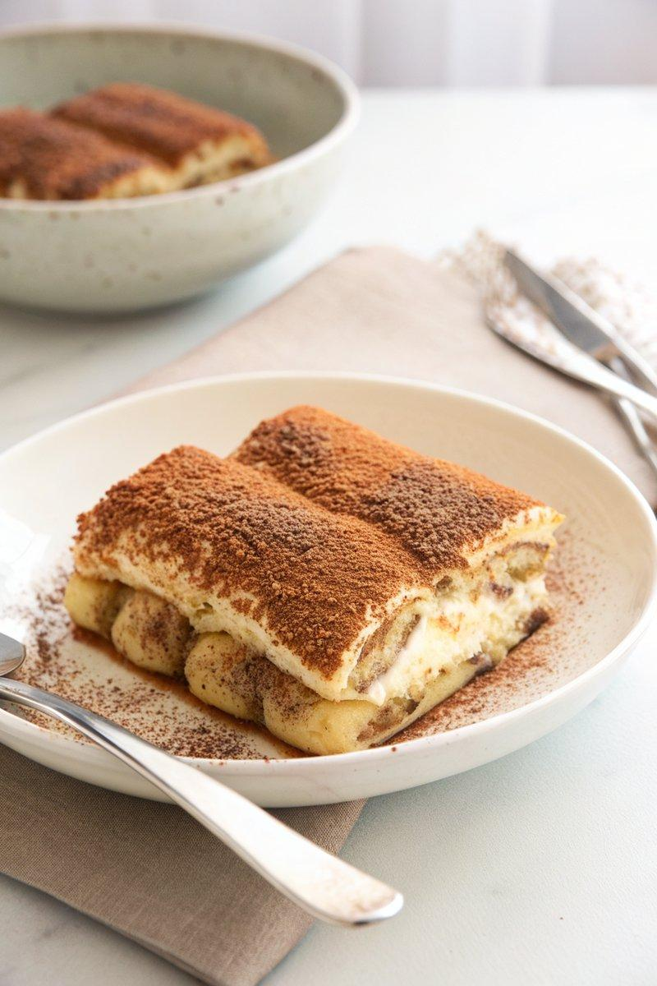

INGREDIENTS  - {'group': 'Main', 'item': '24-30 ladyfingers'}  - {'group': 'Coffee Mixture', 'item': '500ml freshly brewed espresso or strong coffee, cold'}  - {'group': 'Coffee Mixture', 'item': '50g granulated sugar'}  - {'group': 'Coffee Mixture', 'item': '45ml brandy or rum (optional)'}  - {'group': 'Coffee Mixture', 'item': 'Splash of pure maple syrup (optional)'}  - {'group': 'Coffee Mixture', 'item': 'Pinch of freshly grated nutmeg (optional)'}  - {'group': 'Zabaglione Cream', 'item': '6-7 large egg yolks'}  - {'group': 'Zabaglione Cream', 'item': '150g granulated sugar'}  - {'group': 'Zabaglione Cream', 'item': '452g mascarpone, room temperature'}  - {'group': 'Zabaglione Cream', 'item': '250ml heavy whipping cream'}  - {'group': 'Garnish', 'item': 'Cocoa powder, for sifting'}  - {'group': 'Garnish', 'item': 'Dark chocolate, for grating'} | PREP  Prepare the coffee mixture by whisking together the espresso, sugar, brandy or rum, maple syrup, and nutmeg in a shallow dish. Set aside.  COOK  For the zabaglione, place egg yolks and sugar in a heatproof bowl over simmering water. Whisk until sugar dissolves and the mixture is warm. Beat with a mixer until it triples in volume and forms soft peaks. In another bowl, beat mascarpone until smooth, then fold into the egg mixture. Whip the cream to medium peaks and gently fold into the mascarpone mixture.  PLATING  Dip ladyfingers quickly in the coffee mixture and layer them in a 23-cm square pan. Spread half of the zabaglione cream over the ladyfingers. Repeat with another layer of dipped ladyfingers and the remaining cream. Cover and refrigerate overnight. Before serving, dust with cocoa powder and grate dark chocolate on top.

NOTES:
Store leftovers tightly covered in the refrigerator for up to 3 days.

