HAZELNUT RUSSIAN TEA CAKES  COOK TIME: 10-12 mins  SOURCE: Unknown  #cookies #Russian #bake | 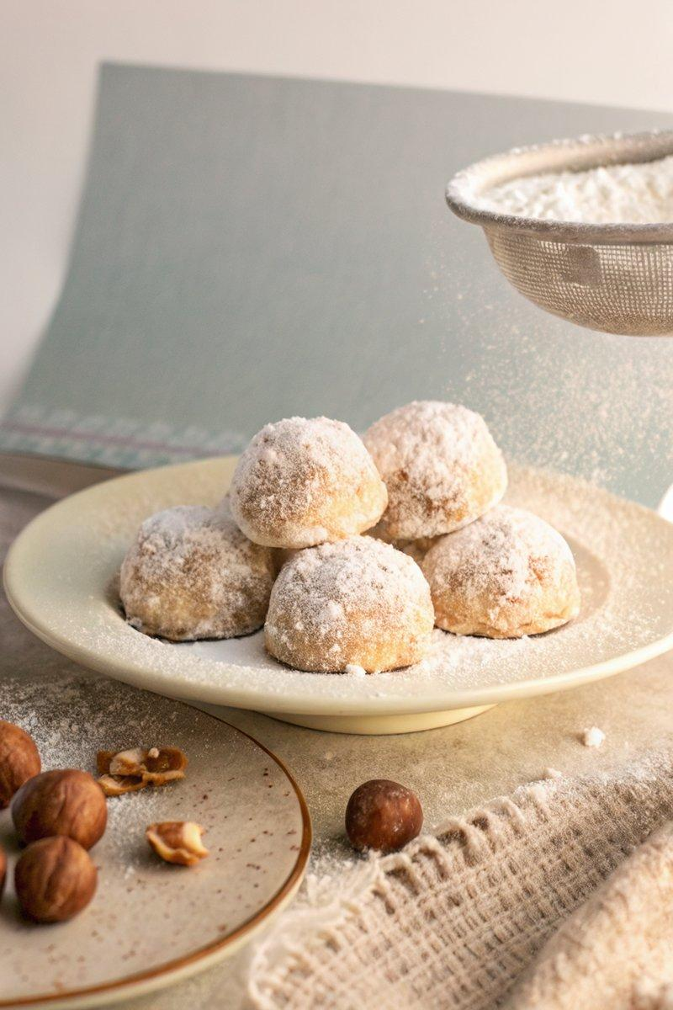

INGREDIENTS  - {'group': 'Main', 'item': '224g unsalted butter, softened'}  - {'group': 'Main', 'item': '150g powdered sugar, plus more for coating'}  - {'group': 'Main', 'item': '5ml pure vanilla extract'}  - {'group': 'Main', 'item': '338g unbleached all-purpose flour'}  - {'group': 'Main', 'item': '12g fine sea salt'}  - {'group': 'Main', 'item': '97g finely chopped raw hazelnuts'} | PREP  Preheat the oven to 200°C (400°F (200°C)) and line a baking sheet with parchment paper. In a large bowl, use a handheld mixer to beat together the softened butter, 150g powdered sugar, and vanilla extract until light and creamy, about 1-2 minutes. In a separate bowl, whisk together the all-purpose flour and sea salt.  COOK  Gradually stir the flour mixture into the butter mixture using a wooden spoon until a homogeneous dough forms. Fold in the chopped hazelnuts. Roll the dough into 2.5cm balls and place them on the prepared baking sheet, spaced 2.5cm apart. Bake for 10-12 minutes, or until the cookies are just set.  PLATING  While the cookies are still warm but cool enough to handle, roll each one in additional powdered sugar. Place the coated cookies on a wire rack to cool completely. Optionally, sprinkle more powdered sugar over the top before serving.

NOTES:
Store any leftovers in an airtight container at room temperature for up to 4 days.

