STRAWBERRY SHORTCAKE WITH BISCUITS  COOK TIME: 15-17 mins  SOURCE: Unknown  #strawberry #American #bake | 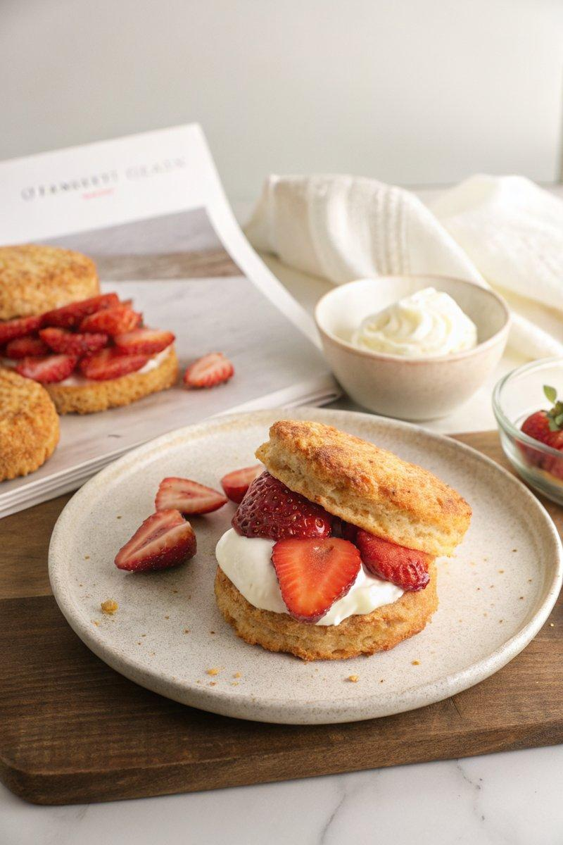

INGREDIENTS  - {'group': 'Main', 'item': '450g strawberries, hulled and sliced'}  - {'group': 'Main', 'item': '50g granulated sugar, divided'}  - {'group': 'Main', 'item': '1g muscovado sugar'}  - {'group': 'Main', 'item': 'Pinch of sea salt'}  - {'group': 'Main', 'item': '250ml heavy whipping cream'}  - {'group': 'Biscuits', 'item': '450g all-purpose flour, plus more for dusting'}  - {'group': 'Biscuits', 'item': '50g granulated sugar'}  - {'group': 'Biscuits', 'item': '21g baking powder'}  - {'group': 'Biscuits', 'item': '1 tsp fine sea salt'}  - {'group': 'Biscuits', 'item': '160g unsalted butter, cold and cubed'}  - {'group': 'Biscuits', 'item': '250ml cold buttermilk, plus more for brushing'}  - {'group': 'Biscuits', 'item': '1 large egg yolk'}  - {'group': 'Biscuits', 'item': 'Zest of 1 lemon'}  - {'group': 'Biscuits', 'item': 'Demerara sugar, for sprinkling'} | PREP  In a large bowl, combine the strawberries with 38g of granulated sugar, muscovado sugar, and a pinch of salt. Toss to coat and refrigerate. For the biscuits, whisk together flour, granulated sugar, baking powder, and salt in a medium bowl.  COOK  Preheat the oven to 220°C (425°F (220°C)). In a food processor, pulse the flour mixture with cold butter until it resembles pea-sized crumbs. Transfer back to the bowl, add buttermilk, egg yolk, and lemon zest, mixing until a dough forms. Roll the dough into a 25cm (10-inch) rectangle, fold into thirds, roll again, and fold once more. Wrap in plastic and chill for 10 mins. Roll out dough to 1.25cm (10-inch) thick, cut into biscuits, and place on lined baking sheets. Brush with buttermilk, sprinkle with demerara sugar, and bake for 15-17 mins until golden brown. Cool completely.  PLATING  Whip the heavy cream with the remaining sugar until stiff peaks form. To assemble, split each biscuit, layer with whipped cream and strawberries, and top with the biscuit lid. Optionally, add more cream and strawberries on top before serving.

NOTES:
Ensure the butter is cold for the biscuits to achieve a flaky texture. The strawberries can be prepared a few hours in advance to allow the flavours to meld.

