SOFT AND CHEWY PEANUT BUTTER COOKIES  COOK TIME: 12-14 mins  SOURCE: Unknown  #peanut butter #American #bake | 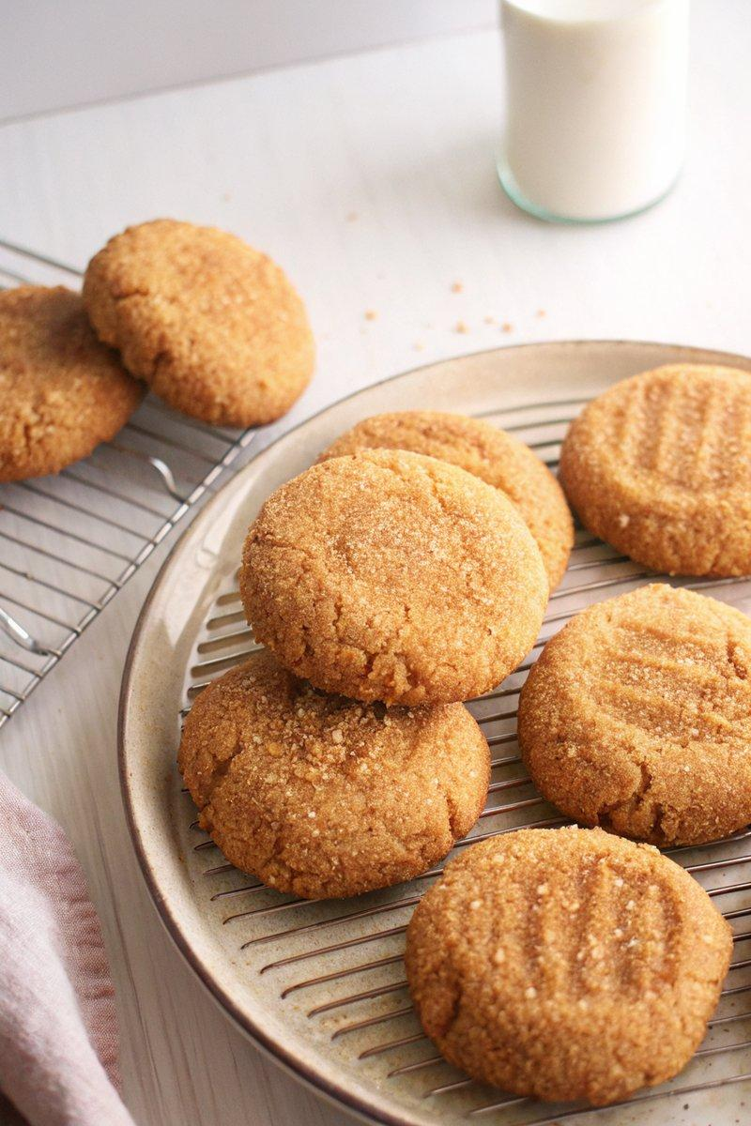

INGREDIENTS  - {'group': 'Main', 'item': '338g all-purpose flour'}  - {'group': 'Main', 'item': '5g baking soda'}  - {'group': 'Main', 'item': '90g fine sea salt'}  - {'group': 'Main', 'item': '215g light brown sugar'}  - {'group': 'Main', 'item': '100g granulated sugar'}  - {'group': 'Main', 'item': '224g unsalted butter, melted'}  - {'group': 'Main', 'item': '256g creamy peanut butter'}  - {'group': 'Main', 'item': '2 large eggs'}  - {'group': 'Main', 'item': '10ml pure vanilla extract'}  - {'group': 'Coating', 'item': 'Turbinado sugar'} | PREP  Preheat the oven to 180°C (350°F (175°C)) and line two baking sheets with parchment paper. In a medium bowl, whisk together the flour, baking soda, and salt. In another bowl, combine the brown sugar and granulated sugar, then gradually whisk in the melted butter, followed by the peanut butter, eggs, and vanilla extract.  COOK  Combine the flour mixture with the sugar mixture, stirring until fully incorporated. Roll the dough into 12 equal balls, about 100g each. Coat each ball in turbinado sugar and place them on the baking sheets, spacing them 5cm apart. Gently flatten each ball with your palm or the bottom of a cup.  PLATING  Bake the cookies for 12 to 14 minutes until they are lightly golden. Allow them to cool completely on a wire rack before serving. Store any leftovers in an airtight container at room temperature for up to 3 days.

NOTES:
These cookies are best enjoyed fresh but can be stored for a few days. The turbinado sugar adds a delightful crunch to the exterior.

