SPICY GOCHUJANG CHICKEN NOODLE SOUP  COOK TIME: 3 hrs  SOURCE: Unknown  #chicken #asian #slow-cook | 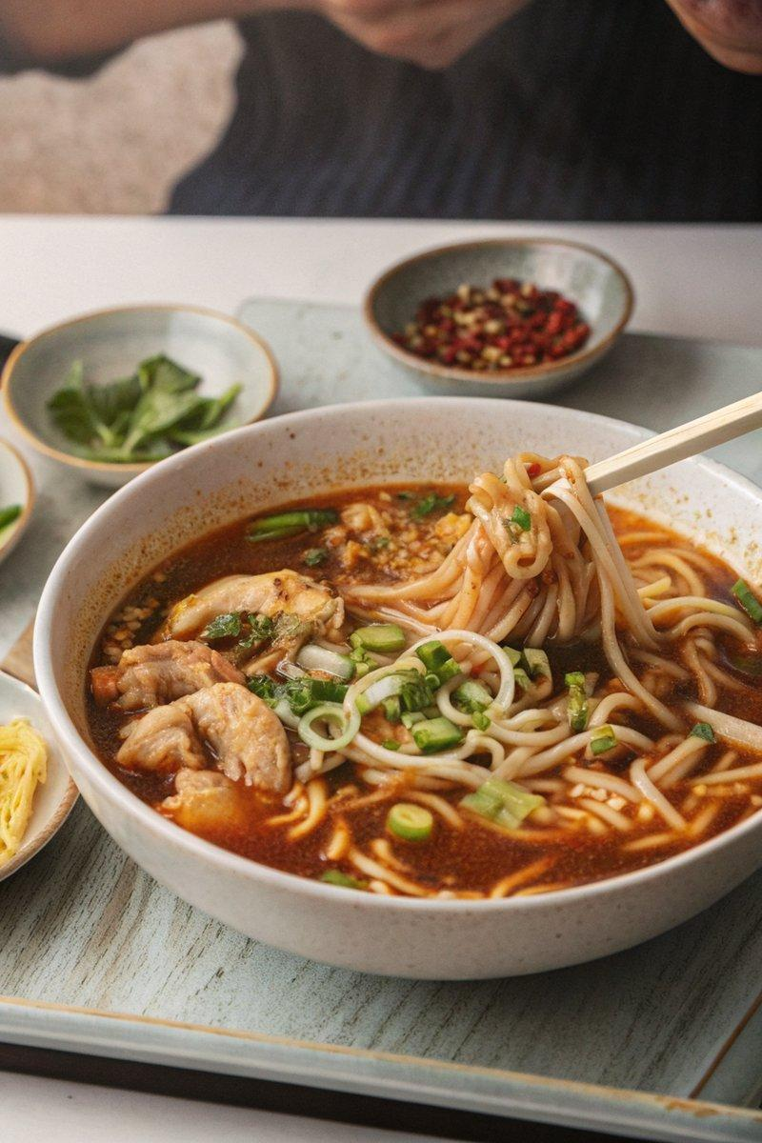

INGREDIENTS  - {'group': 'Main', 'item': '4-6 skinless, bone-in chicken thighs'}  - {'group': 'Main', 'item': '2 garlic cloves, finely chopped'}  - {'group': 'Main', 'item': '1 thumb-size piece ginger, peeled and finely chopped'}  - {'group': 'Sauce', 'item': '1 tsp sesame oil'}  - {'group': 'Sauce', 'item': '2 tsp dark soy sauce, plus extra to taste'}  - {'group': 'Sauce', 'item': '2-3 tbsp gochujang chilli paste'}  - {'group': 'Sauce', 'item': '2 tsp red or white miso paste'}  - {'group': 'Main', 'item': '½ head of Chinese cabbage, roughly chopped'}  - {'group': 'Main', 'item': '300g medium straight-to-wok noodles'}  - {'group': 'Garnish', 'item': '2 spring onions, thinly sliced'} | PREP  Finely chop the garlic and ginger. Roughly chop the Chinese cabbage. Thinly slice the spring onions for garnish.  COOK  In a slow cooker, combine the chicken thighs, garlic, ginger, sesame oil, soy sauce, gochujang, miso paste, and 1L of water. Mix well. Cover and cook on high for 3 hours or on low for 5 hours until the chicken is tender. Remove the chicken, add the cabbage, and cover again. Shred the chicken and return it to the slow cooker with the noodles. Cook for an additional 5 mins on high or 10 mins on low until the noodles are heated through. Adjust seasoning with extra soy sauce if needed.  PLATING  Serve the soup in deep bowls, garnished with sliced spring onions. Optionally, add charred sweetcorn, crispy chilli oil, or soy-marinated eggs for extra flavour.

NOTES:
For a complete meal, serve with a side of kimchi. Adjust the spice level by varying the amount of gochujang.

