BROCCOLI AND CHEESE SOUP  COOK TIME: 4 hrs on high or 5-6 hrs on low  SOURCE: Unknown  #vegetarian #American #slow-cook | 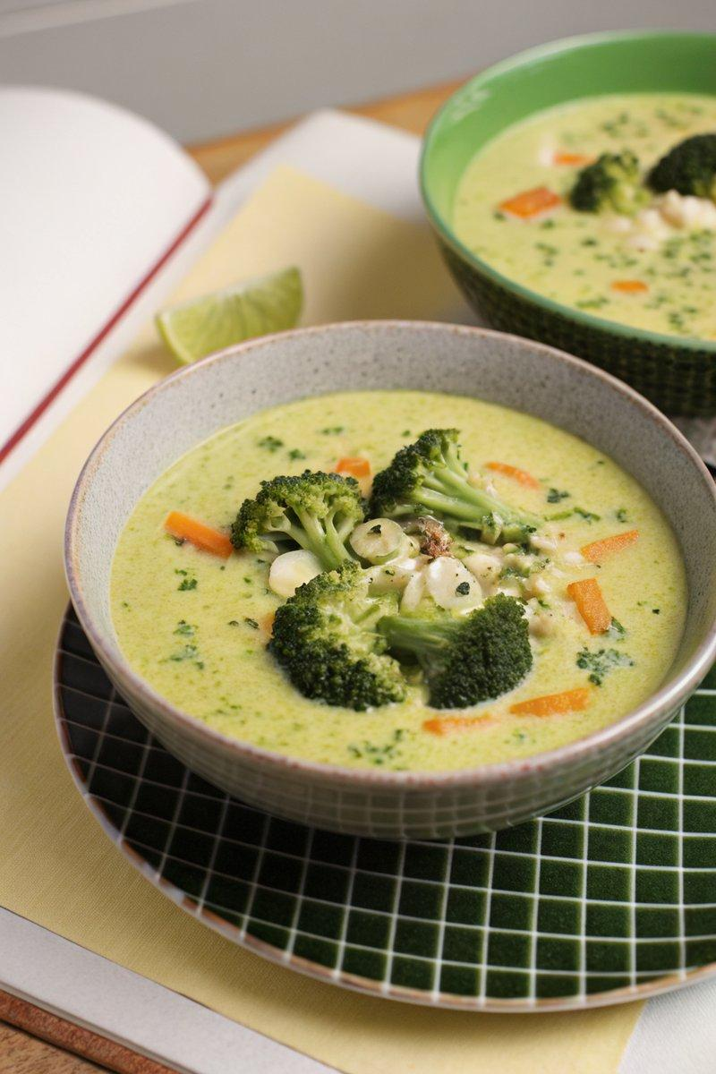

INGREDIENTS  - {'group': 'Main', 'item': '2 broccoli heads, florets and stalks chopped'}  - {'group': 'Main', 'item': '1 onion, chopped'}  - {'group': 'Main', 'item': '1 carrot, chopped'}  - {'group': 'Main', 'item': '1 small leek, sliced'}  - {'group': 'Main', 'item': '2 garlic cloves, finely chopped'}  - {'group': 'Main', 'item': '1.1 L chicken or vegetable stock'}  - {'group': 'Main', 'item': '100g extra-mature cheddar, grated'}  - {'group': 'Main', 'item': '100ml double cream'}  - {'group': 'Seasoning', 'item': 'Salt and black pepper'} | PREP  Cut the broccoli into florets and chop the stalks. Chop the onion, carrot, and leek. Finely chop the garlic.  COOK  Place the chopped broccoli, onion, carrot, leek, and garlic into the slow cooker. Season with salt and pepper. Pour in the stock, cover, and cook on high for 4 hours or on low for 5-6 hours until the broccoli is tender. Add most of the cheddar cheese, reserving a little for garnish, and cook for an additional 15 minutes on high. Stir in the double cream, then blend the soup until smooth using a hand-held stick blender.  PLATING  Serve the soup hot, garnished with the reserved cheddar cheese. Optionally, top with crispy air-fried or oven-baked broccoli florets for added texture.

NOTES:
For crispy broccoli garnish, drizzle reserved florets with oil and air-fry at 200°C (400°F (200°C)) for 10 minutes, or bake in the oven at 200°C (400°F (200°C)) for 10-15 minutes.

