SPICY COCONUT LAKSA SOUP  COOK TIME: 3 hrs 20 mins  SOURCE: Unknown  #soup #asian #slow-cook | 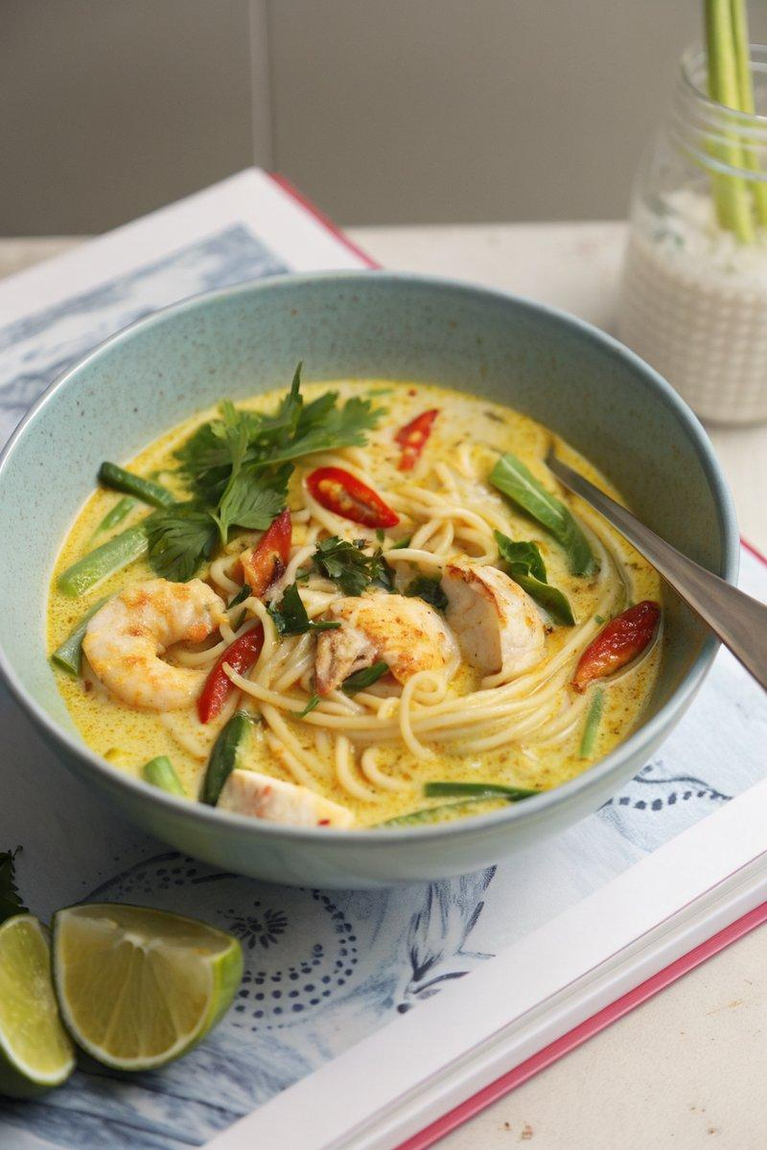

INGREDIENTS  - {'group': 'Main', 'item': '3-4 tbsp laksa paste'}  - {'group': 'Main', 'item': '2 lemongrass sticks, bruised'}  - {'group': 'Main', 'item': 'handful of fresh curry leaves'}  - {'group': 'Main', 'item': '400ml full-fat coconut milk'}  - {'group': 'Main', 'item': '1L chicken or vegetable stock'}  - {'group': 'Main', 'item': '1 tsp light brown soft or palm sugar'}  - {'group': 'Main', 'item': '1 tsp salt or dark soy sauce'}  - {'group': 'Main', 'item': '200g green beans, trimmed'}  - {'group': 'Main', 'item': '100g bean sprouts'}  - {'group': 'Main', 'item': '300g medium straight-to-wok rice noodles'}  - {'group': 'Garnish', 'item': '3-4 limes, halved'}  - {'group': 'Garnish', 'item': 'small handful of coriander, roughly chopped'}  - {'group': 'Garnish', 'item': '2-3 red chillies, deseeded and thinly sliced'} | PREP  If making homemade laksa paste, blend 4 chopped shallots, a thumb-sized piece of peeled ginger, 4 peeled garlic cloves, 2 red chillies, a handful of coriander, 2 tsp mild curry powder, and 2 chopped lemongrass sticks into a coarse paste.  COOK  In a slow cooker, combine the laksa paste, bruised lemongrass, curry leaves, coconut milk, stock, sugar, and salt or soy sauce. Cover and cook on high for 3 hours until fragrant. Stir in the green beans, bean sprouts, noodles, and juice from half the lime halves. Cover and cook for another 15-20 mins until the vegetables are tender.  PLATING  Remove the lemongrass sticks and divide the laksa into bowls. Garnish with coriander and sliced chillies. Serve with lime wedges on the side for squeezing.

NOTES:
For added protein, marinate prawns in laksa paste and fry them to serve on top. Alternatively, add chicken breasts at the start or serve with crispy pork belly or tofu.

