SLOW COOKER TOFU RAMEN  COOK TIME: 4 hrs 10 mins  SOURCE: Unknown  #tofu #asian #slow-cook | 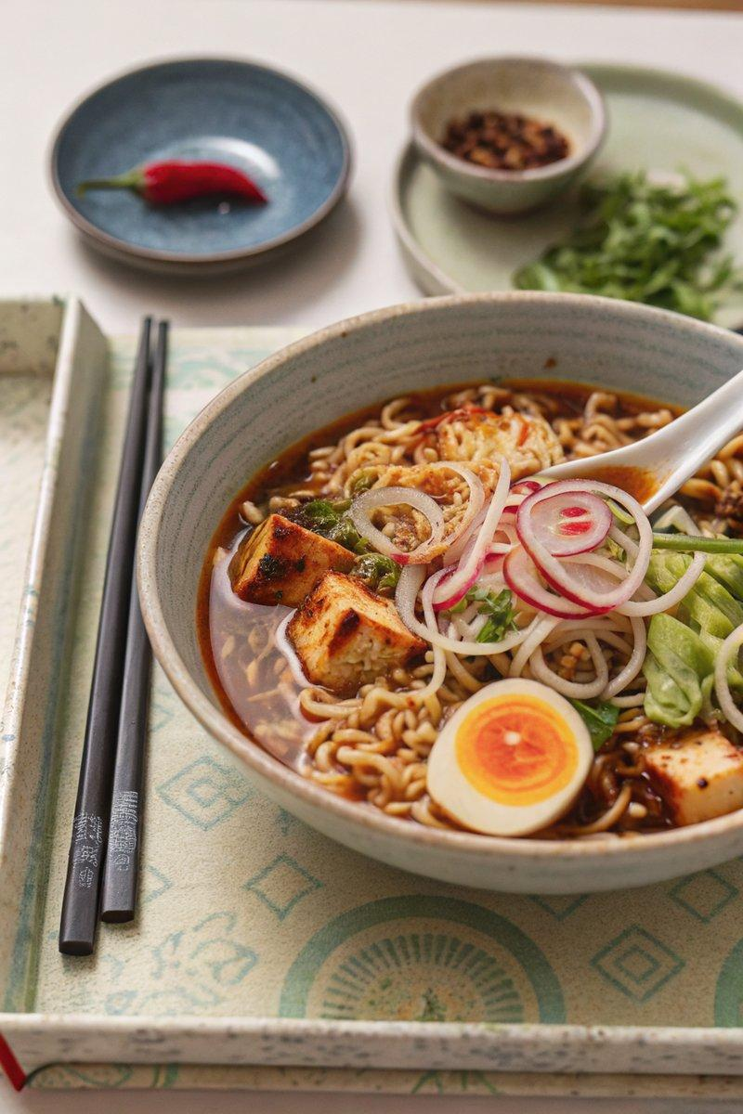

INGREDIENTS  - {'group': 'Main', 'item': '2 onions, thinly sliced'}  - {'group': 'Main', 'item': 'thumb-sized piece of ginger, peeled and julienned'}  - {'group': 'Main', 'item': '4 garlic cloves, grated'}  - {'group': 'Main', 'item': '2-4 red chillies, deseeded and thinly sliced'}  - {'group': 'Main', 'item': '2 x 280g blocks of firm tofu, drained and cut into 1cm pieces'}  - {'group': 'Main', 'item': '4 tbsp white miso paste'}  - {'group': 'Main', 'item': '4 L chicken stock'}  - {'group': 'Main', 'item': '4 x 100g nests of instant ramen noodles, including seasoning sachets'}  - {'group': 'Garnish', 'item': '½ leek or 8 spring onions, shredded'}  - {'group': 'Seasoning', 'item': 'dark soy sauce, to taste'}  - {'group': 'Seasoning', 'item': 'your favourite chilli oil, to taste'} | PREP  Thinly slice the onions and chillies, julienne the ginger, and grate the garlic. Drain and cut the tofu into 1cm pieces. Shred the leek or spring onions.  COOK  Place the onions, ginger, garlic, chillies, tofu, miso paste, chicken stock, and noodle seasoning sachets into the slow cooker. Cover and cook on high for 4 hours until the onions are softened. When nearly done, soak the shredded leek or spring onions in ice-cold water to curl. Add the ramen noodles to the slow cooker and cook for an additional 5-10 mins until just tender.  PLATING  Divide the ramen into deep bowls. Season with soy sauce and chilli oil to taste. Drain the leek or spring onions and add a handful to each bowl before serving.

NOTES:
For an extra touch, consider adding soy-marinated eggs. Hard boil and peel 4 eggs, then marinate them overnight in a mixture of grated garlic, soy sauce, mirin, sesame oil, and chilli flakes. Halve the eggs and place them atop the ramen before serving.

