CARROT AND CARAWAY SOUP  COOK TIME: 4 hrs  SOURCE: Unknown  #vegetarian #mediterranean #slow-cook | 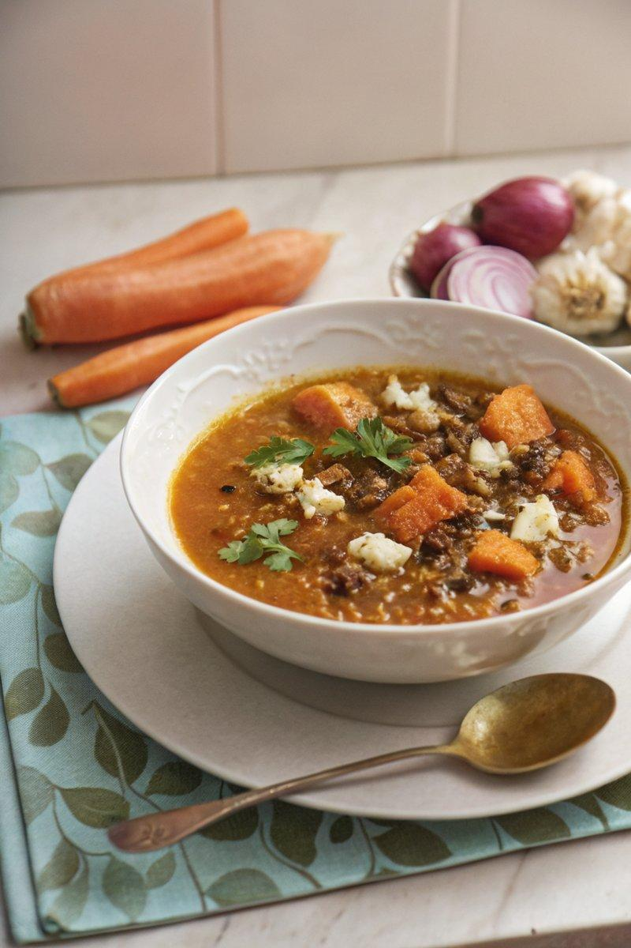

INGREDIENTS  - {'group': 'Main', 'item': '500g carrots, halved lengthways and cut into 2cm slices'}  - {'group': 'Main', 'item': '1 tbsp tomato purée'}  - {'group': 'Main', 'item': '2 celery sticks, finely diced'}  - {'group': 'Main', 'item': '1 red onion, finely diced'}  - {'group': 'Main', 'item': '2 garlic cloves, grated or crushed'}  - {'group': 'Main', 'item': '1 rosemary sprig, leaves picked'}  - {'group': 'Main', 'item': '400g can of brown lentils, rinsed and drained'}  - {'group': 'Main', 'item': '½ tsp caraway seeds'}  - {'group': 'Main', 'item': '1 tsp cumin seeds'}  - {'group': 'Main', 'item': 'Pinch of chilli flakes'}  - {'group': 'Main', 'item': '800ml chicken or vegetable stock'}  - {'group': 'Seasoning', 'item': 'Salt and black pepper'}  - {'group': 'Garnish', 'item': 'Crème fraiche'}  - {'group': 'Garnish', 'item': 'Feta, crumbled'}  - {'group': 'Garnish', 'item': 'Small handful of coriander, leaves roughly chopped'}  - {'group': 'Garnish', 'item': 'Crispy lentils'}  - {'group': 'Garnish', 'item': 'Garlic croutons'} | PREP  Prepare the carrots by halving them lengthways and slicing into 2cm pieces. Finely dice the celery and onion, and grate or crush the garlic cloves. Pick the leaves from the rosemary sprig.  COOK  In a slow cooker, combine the carrots, tomato purée, celery, onion, garlic, rosemary leaves, lentils, caraway seeds, cumin seeds, and chilli flakes. Pour in the stock and season with 1 tsp of salt and plenty of black pepper. Stir well and cook on high for 4 hours until the carrots are tender. Once cooked, use a hand-held stick blender to roughly blend half of the soup, leaving some texture.  PLATING  Divide the soup into four bowls. Add a dollop of crème fraiche to each serving and garnish with crumbled feta, chopped coriander, crispy lentils, and garlic croutons as desired.

NOTES:
For a variation, substitute feta with soft goat's cheese or use dill or parsley instead of coriander. Serve with homemade flatbread for a complete meal.

