CREAMY MUSHROOM SOUP  COOK TIME: 3 hrs 30 mins  SOURCE: Unknown  #mushroom #European #slow-cook | 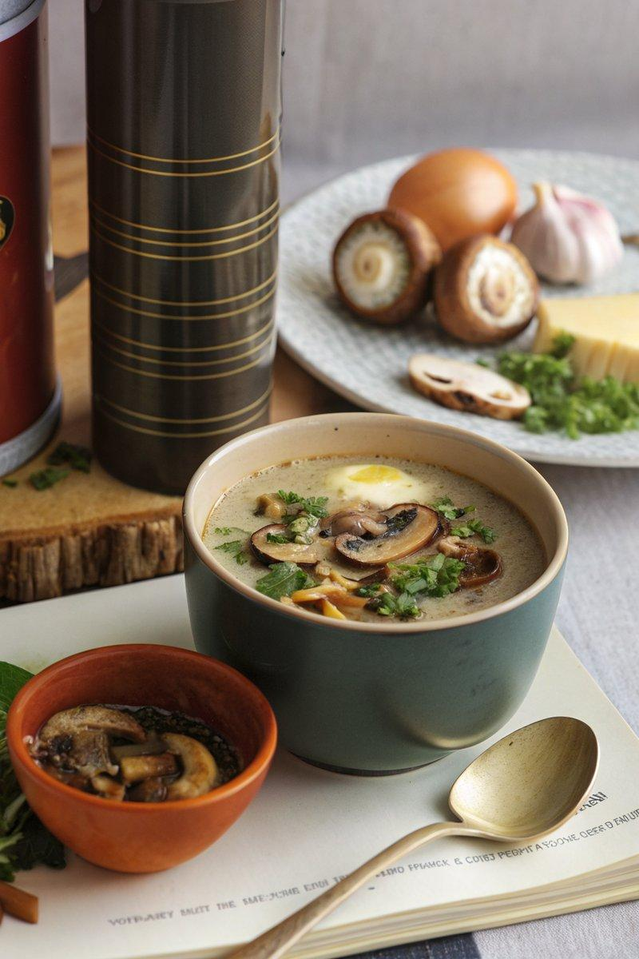

INGREDIENTS  - {'group': 'Main', 'item': '300g chestnut mushrooms, roughly sliced'}  - {'group': 'Main', 'item': '3 large flat field mushrooms, roughly sliced'}  - {'group': 'Main', 'item': '3 garlic cloves, sliced'}  - {'group': 'Main', 'item': '1 large onion, sliced'}  - {'group': 'Main', 'item': 'vegetable oil, for drizzling'}  - {'group': 'Main', 'item': '30g dried mushrooms (such as porcini)'}  - {'group': 'Main', 'item': '2 tbsp balsamic vinegar'}  - {'group': 'Main', 'item': '50ml brandy'}  - {'group': 'Main', 'item': '1 vegetable stock cube'}  - {'group': 'Main', 'item': '½ tbsp yeast extract'}  - {'group': 'Main', 'item': '80g butter, cubed'}  - {'group': 'Garnish', 'item': 'small handful of parsley leaves, roughly chopped (optional)'}  - {'group': 'Seasoning', 'item': 'salt and black pepper'} | PREP  Preheat the oven to 180°C (160°C (320°F (160°C)) fan). Slice the chestnut and field mushrooms, garlic, and onion. Rehydrate the dried mushrooms in boiling water for 10 minutes, then drain and chop.  COOK  Place the fresh mushrooms, garlic, and onion in a roasting tray. Drizzle with vegetable oil, season with salt and pepper, and roast for 15-20 minutes until starting to colour. Add balsamic vinegar, chopped dried mushrooms, and brandy to the tray, then roast for another 10 minutes until golden. Transfer the mushroom mixture to a slow cooker, add the stock cube, and cover with boiling water. Stir in the yeast extract and cook on high for 3 hours or low for 4 hours.  PLATING  Blend the soup until smooth using a hand-held blender, incorporating the butter cubes gradually. Adjust seasoning to taste. Serve hot, garnished with parsley if desired.

NOTES:
For an extra touch, serve with a poached egg in the centre of the bowl, allowing the yolk to enrich the soup. Drizzle with extra-virgin olive oil for added flavour.

