ROASTED TOMATO SOUP  COOK TIME: 3 hrs 15 mins  SOURCE: Unknown  #tomato #Mediterranean #slow-cook | 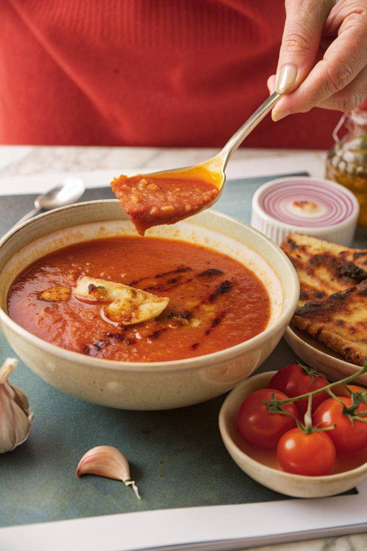

INGREDIENTS  - {'group': 'Main', 'item': '1kg tomatoes, assorted shapes and sizes'}  - {'group': 'Main', 'item': '1 onion, sliced'}  - {'group': 'Main', 'item': '2 garlic cloves, grated or crushed'}  - {'group': 'Main', 'item': '25ml balsamic vinegar, plus extra if needed'}  - {'group': 'Main', 'item': 'Vegetable oil, for drizzling'}  - {'group': 'Main', 'item': '1 jar roasted red peppers, drained and roughly chopped'}  - {'group': 'Main', 'item': '3-4 sun-dried tomatoes, drained and chopped'}  - {'group': 'Main', 'item': '200ml tomato passata'}  - {'group': 'Main', 'item': '1 tbsp tomato purée'}  - {'group': 'Main', 'item': '1 chicken or vegetable stock cube, crumbled'}  - {'group': 'Garnish', 'item': 'Small handful of basil leaves, picked'}  - {'group': 'Main', 'item': '50g butter, cubed'}  - {'group': 'Seasoning', 'item': 'White sugar, to taste if needed'}  - {'group': 'Seasoning', 'item': 'Salt and black pepper'} | PREP  Preheat the oven to 200°C (400°F)/180°C (350°F (175°C)) fan. Slice the onion and grate or crush the garlic. Drain and chop the roasted red peppers and sun-dried tomatoes. Pick the basil leaves.  COOK  Place the tomatoes, onion, and garlic in a roasting tin. Drizzle with vegetable oil and balsamic vinegar, season with salt and pepper, and toss to coat. Roast in the oven for 10-15 mins until blistered and slightly charred. Transfer the roasted mixture to a slow-cooker. Add the roasted red peppers, sun-dried tomatoes, tomato passata, tomato purée, and crumbled stock cube. Pour in 550ml of water. Cover and cook on high for 3 hrs or low for 4 hrs until the tomatoes are soft. Add most of the basil leaves and blend the soup with a hand-held blender, incorporating the butter cubes gradually. Adjust seasoning with salt, balsamic vinegar, or sugar as needed.  PLATING  Serve the soup hot, garnished with the remaining basil leaves. Pair with a grilled cheese sandwich for a complete meal.

NOTES:
For a spicy twist, add a touch of chili jam to your grilled cheese sandwich. The soup can be adjusted for sweetness or acidity by adding sugar or balsamic vinegar to taste.

