CHIPOTLE BEAN SOUP  COOK TIME: 4 hrs 10 mins  SOURCE: Unknown  #vegetarian #Mexican #slow-cook | 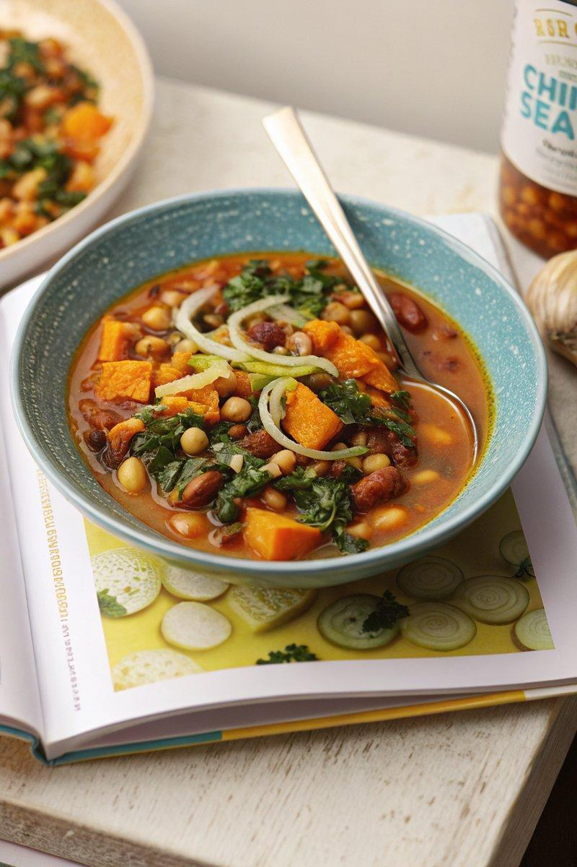

INGREDIENTS  - {'group': 'Main', 'item': '1 onion, thinly sliced'}  - {'group': 'Main', 'item': '1 butternut squash, peeled, deseeded, and cut into 1cm dice'}  - {'group': 'Main', 'item': '2 celery sticks, finely diced'}  - {'group': 'Main', 'item': '2 garlic cloves, grated or crushed'}  - {'group': 'Main', 'item': 'small handful of thyme leaves, picked'}  - {'group': 'Main', 'item': '1 x 400g can of cannellini beans, drained'}  - {'group': 'Main', 'item': '1 x 400g can of borlotti beans, drained'}  - {'group': 'Main', 'item': '1-2 tbsp chipotle paste'}  - {'group': 'Main', 'item': '½-1 tsp cayenne pepper'}  - {'group': 'Main', 'item': '1 tsp dried oregano'}  - {'group': 'Main', 'item': '800ml chicken or vegetable stock'}  - {'group': 'Main', 'item': '200g cavolo nero, sliced'}  - {'group': 'Seasoning', 'item': 'salt and black pepper'}  - {'group': 'Garnish', 'item': 'sea-salt flakes and chilli flakes or sliced red chilli'} | PREP  Prepare the vegetables by slicing the onion, dicing the butternut squash, and finely dicing the celery. Grate or crush the garlic cloves and pick the thyme leaves.  COOK  In a slow cooker, combine the onion, butternut squash, celery, garlic, thyme, cannellini beans, borlotti beans, chipotle paste, cayenne pepper, oregano, and stock. Season with 1 tsp of salt and plenty of black pepper. Cover and cook on high for 4 hours until the squash is tender. Use a hand-held blender to purée roughly half of the soup to thicken it. Stir in the cavolo nero, cover, and cook for an additional 10 minutes on high until the greens are tender. Adjust seasoning as needed.  PLATING  Divide the soup into four bowls. Garnish each serving with a pinch of sea-salt flakes and a sprinkle of chilli flakes or sliced red chilli.

NOTES:
Feel free to use any beans you have on hand. If cavolo nero is unavailable, substitute with another type of cabbage or spinach.

