FRENCH ONION SOUP WITH GRUYÈRE  COOK TIME: 4 hrs on high or 8 hrs on low, plus 5-10 mins under grill  SOURCE: Unknown  #onion #French #slow-cook | 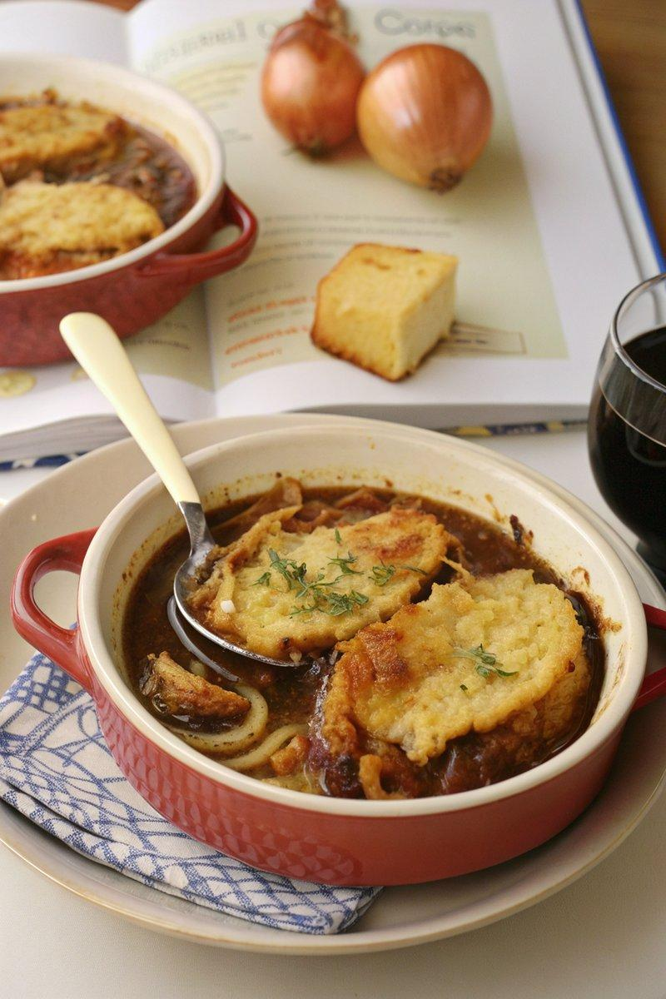

INGREDIENTS  - {'group': 'Main', 'item': '750g onions, thinly sliced'}  - {'group': 'Main', 'item': 'small handful of thyme, leaves picked'}  - {'group': 'Main', 'item': '1 bay leaf (optional)'}  - {'group': 'Main', 'item': '30g butter, cubed'}  - {'group': 'Main', 'item': '1.2L beef stock'}  - {'group': 'Main', 'item': '200ml dry white wine'}  - {'group': 'Main', 'item': 'splash of olive oil (optional)'}  - {'group': 'Main', 'item': '½ tbsp cornflour, slackened with water (optional)'}  - {'group': 'Topping', 'item': '1 baguette, sliced'}  - {'group': 'Topping', 'item': '150g gruyère or emmental, grated'}  - {'group': 'Seasoning', 'item': 'salt and black pepper'} | PREP  Thinly slice the onions and pick the thyme leaves. Cube the butter and slacken the cornflour with water if using.  COOK  In a slow cooker, combine the onions, thyme, bay leaf, butter, beef stock, white wine, and olive oil. Season with salt and black pepper. Cover and cook on high for 4 hours or on low for 8 hours until the onions are tender. Adjust seasoning as needed. If a thicker consistency is desired, stir in the cornflour slurry.  PLATING  Preheat the grill to high. If the slow cooker bowl is oven-safe, place the baguette slices on top of the soup and sprinkle with grated cheese. Grill for 5-10 minutes until the cheese is golden and bubbling. Alternatively, ladle the soup into heatproof bowls, top with baguette and cheese, and grill until the cheese is melted and bubbly.

NOTES:
This soup can be frozen. To serve, defrost and reheat, then top with fresh baguette and cheese before grilling.

