THAI RED CURRY CHICKEN  COOK TIME: 3 hours on high or 6-7 hours on low  SOURCE: Unknown  #chicken #asian #slow-cook | 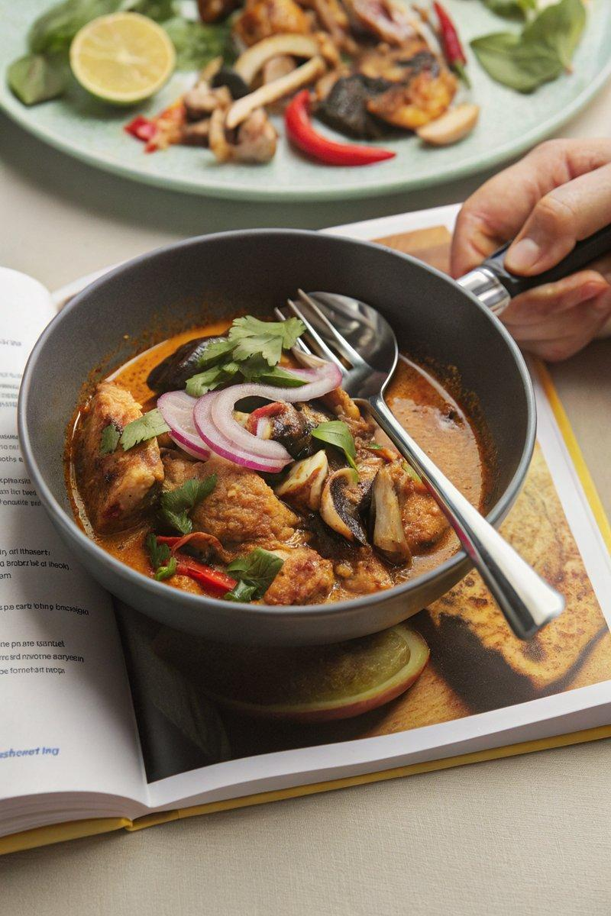

INGREDIENTS  - {'group': 'Main', 'item': '6 skinless, boneless chicken thighs'}  - {'group': 'Main', 'item': '1 red onion, sliced'}  - {'group': 'Main', 'item': '250g closed-cup mushrooms, halved'}  - {'group': 'Main', 'item': '1 lemongrass stick, bruised'}  - {'group': 'Main', 'item': '2 red chillies, split lengthways'}  - {'group': 'Main', 'item': 'thumb-sized piece of ginger, peeled and grated'}  - {'group': 'Main', 'item': 'handful of fresh makrut lime leaves'}  - {'group': 'Sauce', 'item': '400ml full-fat coconut milk'}  - {'group': 'Sauce', 'item': '3 tbsp Thai red curry paste'}  - {'group': 'Sauce', 'item': '1 tbsp dark soy sauce'}  - {'group': 'Sauce', 'item': '1 tsp fish sauce'}  - {'group': 'Sauce', 'item': '1 tsp white sugar'}  - {'group': 'Sauce', 'item': '1 chicken stock cube'}  - {'group': 'Garnish', 'item': '25g Thai basil, leaves picked'}  - {'group': 'Garnish', 'item': '2 limes, halved'}  - {'group': 'Optional', 'item': '1 tbsp cornflour, slackened with water'} | PREP  Prepare the chicken by cutting it into bite-sized pieces. Slice the red onion and halve the mushrooms. Bruise the lemongrass stick and split the chillies lengthways. Peel and grate the ginger.  COOK  Place the chicken, onion, mushrooms, lemongrass, chillies, ginger, and lime leaves into the slow cooker. Add the coconut milk, curry paste, soy sauce, fish sauce, sugar, and crumble in the stock cube. Stir to combine. Cover and cook on high for 3 hours or on low for 6-7 hours until the chicken is tender.  PLATING  Once cooked, stir in the Thai basil leaves and cornflour slurry if using, breaking up any large chicken pieces. Adjust seasoning with additional soy sauce, fish sauce, or sugar to taste. Serve the curry in bowls, removing the lemongrass stick, and garnish with extra Thai basil leaves, sliced red chilli, and a lime half for squeezing.

NOTES:
For a fragrant jasmine rice, cook according to packet instructions, adding a bashed lemongrass stick and a makrut lime leaf to the water.

