SLOW-COOKED CHICKEN IN RED WINE  COOK TIME: 3 hours on high or 6-7 hours on low  SOURCE: Unknown  #chicken #French #slow-cook | 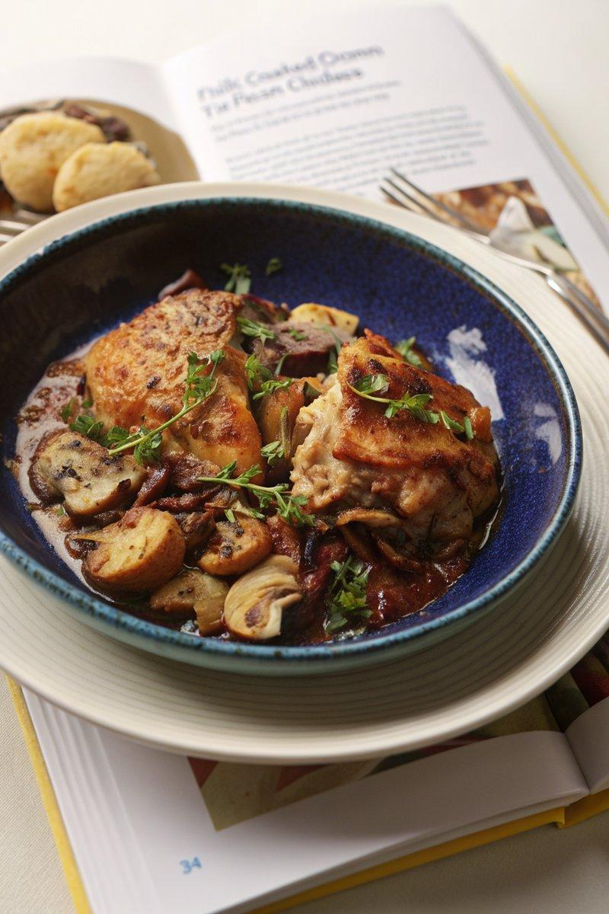

INGREDIENTS  - {'group': 'Main', 'item': '6 skinless, boneless chicken thighs'}  - {'group': 'Main', 'item': '250g shallots, thinly sliced'}  - {'group': 'Main', 'item': '4 garlic cloves, grated or crushed'}  - {'group': 'Main', 'item': '300g chestnut mushrooms, halved'}  - {'group': 'Main', 'item': 'small handful of thyme, leaves picked'}  - {'group': 'Main', 'item': '200g diced pancetta or chopped smoked streaky bacon'}  - {'group': 'Main', 'item': '200ml dry white wine'}  - {'group': 'Main', 'item': 'good knob of butter, cubed'}  - {'group': 'Main', 'item': '1 chicken stock cube, crumbled'}  - {'group': 'Sauce', 'item': '100ml double cream'}  - {'group': 'Garnish', 'item': '30g flat-leaf parsley, roughly chopped'}  - {'group': 'Sauce', 'item': '1 tbsp cornflour, slackened with water (optional)'}  - {'group': 'Seasoning', 'item': 'salt and black pepper'} | PREP  Season the chicken thighs generously with salt. Prepare the shallots by slicing them thinly, and grate or crush the garlic cloves. Halve the chestnut mushrooms and pick the thyme leaves.  COOK  Place the seasoned chicken, shallots, garlic, mushrooms, thyme, pancetta, wine, butter, and crumbled stock cube into the slow cooker. Add a teaspoon of salt and plenty of black pepper. Cover and cook on high for 3 hours or on low for 6-7 hours until the chicken is tender. Once cooked, stir in the double cream, parsley, and cornflour slurry if using, gently breaking up any larger pieces of chicken. Taste and adjust seasoning as needed.  PLATING  Serve the coq au vin hot, spooned onto plates. Garnish with additional parsley if desired.

NOTES:
This dish pairs beautifully with buttery mashed potatoes or dauphinoise potatoes for a complete meal.

