SLOW-COOKED TERIYAKI CHICKEN WITH MUSHROOMS  COOK TIME: 3 hours on high or 6-7 hours on low  SOURCE: Unknown  #chicken #asian #slow-cook | 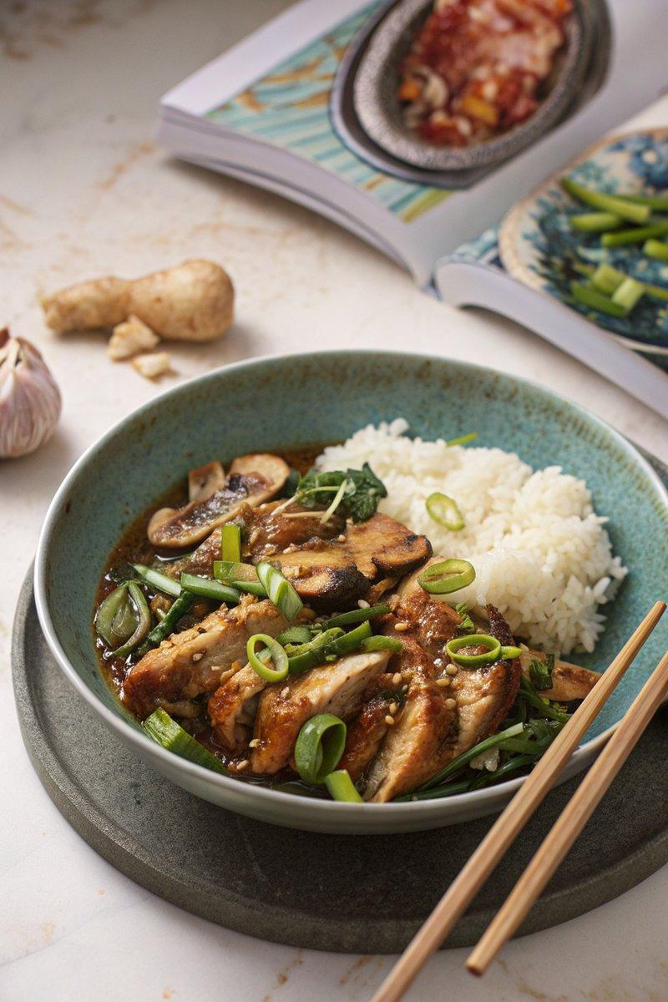

INGREDIENTS  - {'group': 'Main', 'item': '6 skinless, boneless chicken thighs'}  - {'group': 'Main', 'item': '300g shiitake mushrooms, halved if large'}  - {'group': 'Main', 'item': '150g spring onions, sliced into 3cm pieces'}  - {'group': 'Main', 'item': '4 garlic cloves, grated or crushed'}  - {'group': 'Main', 'item': 'thumb-sized piece of ginger, peeled and grated'}  - {'group': 'Sauce', 'item': '6 tbsp teriyaki sauce'}  - {'group': 'Sauce', 'item': '1 chicken stock cube dissolved in 200ml boiling water'}  - {'group': 'Sauce', 'item': 'splash of sesame oil'}  - {'group': 'Optional', 'item': '180-200g sugar snap peas or mangetout'}  - {'group': 'Optional', 'item': '1 tbsp cornflour slackened with water'}  - {'group': 'Seasoning', 'item': 'salt'} | PREP  Season the chicken thighs generously with salt. Halve the shiitake mushrooms if they are large. Slice the spring onions into 3cm pieces. Grate or crush the garlic cloves and peel and grate the ginger.  COOK  Place the chicken thighs, shiitake mushrooms, spring onions, garlic, ginger, teriyaki sauce, chicken stock, and sesame oil into the slow cooker. Stir to combine. Cover and cook on high for 3 hours or on low for 6-7 hours until the chicken is tender. About 30 minutes before the end of cooking, add the sugar snap peas or mangetout if using. Once cooked, stir in the cornflour slurry if desired, breaking up any large pieces of chicken. Adjust seasoning to taste.  PLATING  Serve the teriyaki chicken with sticky rice or flat-rice noodles. Garnish with finely sliced spring onions and toasted sesame seeds if desired.

NOTES:
Leftovers can be used to make a teriyaki chicken melt by adding the chicken to a soft bread roll with cheese and grilling until bubbly.

