SLOW-COOKED CHICKEN FAJITAS  COOK TIME: 3 hours on high or 6-7 hours on low  SOURCE: Unknown  #chicken #Mexican #slow-cook | 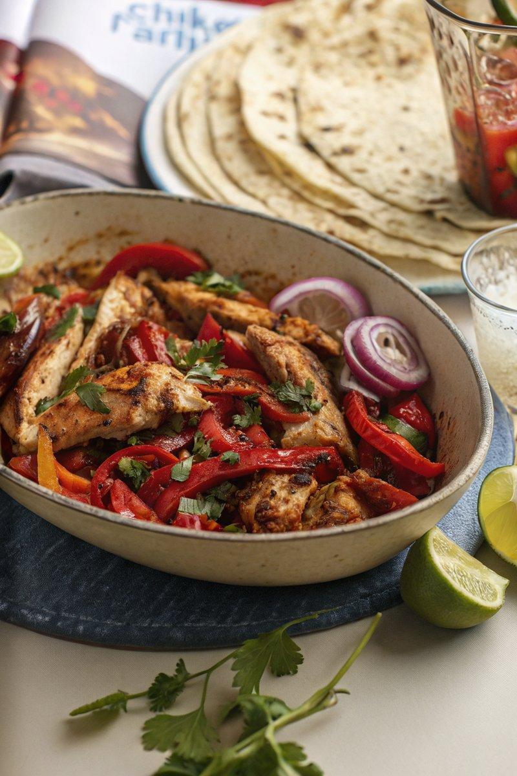

INGREDIENTS  - {'group': 'Main', 'item': '6 skinless, boneless chicken thighs'}  - {'group': 'Main', 'item': '2 red peppers, deseeded and sliced'}  - {'group': 'Main', 'item': '1 red onion, sliced'}  - {'group': 'Main', 'item': '2 garlic cloves, grated or crushed'}  - {'group': 'Seasoning', 'item': 'handful of thyme sprigs, leaves picked'}  - {'group': 'Seasoning', 'item': '1 tsp cayenne pepper'}  - {'group': 'Seasoning', 'item': '1 tsp smoked paprika'}  - {'group': 'Seasoning', 'item': '1/2 tsp ground cumin'}  - {'group': 'Seasoning', 'item': '2 tsp garlic granules'}  - {'group': 'Seasoning', 'item': '2 tsp onion powder'}  - {'group': 'Seasoning', 'item': '1/2-1 tbsp chilli sauce'}  - {'group': 'Seasoning', 'item': 'salt and black pepper'}  - {'group': 'Finishing', 'item': '1-2 limes, juiced'} | PREP  Prepare the chicken by trimming excess fat and slicing the red peppers and onion. Grate or crush the garlic cloves and pick the thyme leaves.  COOK  Place the chicken thighs, red peppers, red onion, garlic, thyme, cayenne pepper, smoked paprika, cumin, garlic granules, onion powder, chilli sauce, salt, and black pepper into the slow cooker. Cover and cook on high for 3 hours or on low for 6-7 hours until the chicken is tender. Once cooked, stir in the lime juice and adjust seasoning if necessary.  PLATING  Remove the chicken from the slow cooker and slice it. Serve with tortillas and your choice of toppings such as cheese, sour cream, and pico de gallo.

NOTES:
For a complete meal, serve with tortilla chips and guacamole. Adjust the chilli sauce to your preferred level of spiciness.

