SLOW-COOKED BACON-WRAPPED CHICKEN WITH BBQ SAUCE  COOK TIME: 2½-3 hrs on high or 6-7 hrs on low  SOURCE: Unknown  #chicken #American #slow-cook | 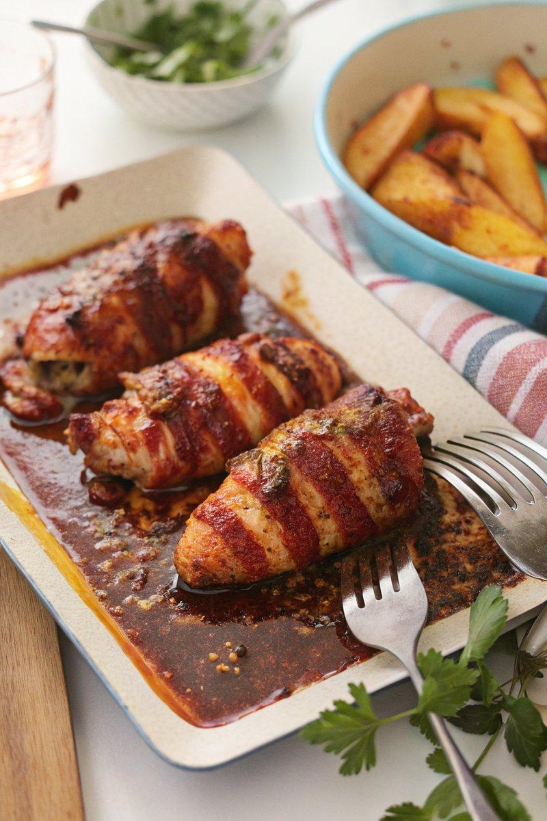

INGREDIENTS  - {'group': 'Main', 'item': '4 skinless, boneless chicken breasts'}  - {'group': 'Main', 'item': '8 rashers of streaky bacon'}  - {'group': 'Sauce', 'item': '200g tomato ketchup'}  - {'group': 'Sauce', 'item': '100ml red wine vinegar'}  - {'group': 'Sauce', 'item': '100g light brown soft sugar'}  - {'group': 'Sauce', 'item': '1 tbsp Worcestershire sauce'}  - {'group': 'Sauce', 'item': '2 tbsp runny honey'}  - {'group': 'Sauce', 'item': '1 heaped tsp smoked paprika'}  - {'group': 'Sauce', 'item': '1 tsp garlic granules'}  - {'group': 'Sauce', 'item': '1 tsp onion salt'}  - {'group': 'Topping', 'item': '150g cheddar, grated'}  - {'group': 'Seasoning', 'item': 'Salt and black pepper'} | PREP  Wrap each chicken breast with two rashers of bacon and season with salt and pepper. In a bowl, combine tomato ketchup, red wine vinegar, brown sugar, Worcestershire sauce, honey, smoked paprika, garlic granules, onion salt, and black pepper to create the BBQ sauce.  COOK  Place the bacon-wrapped chicken breasts in the slow cooker. Pour the BBQ sauce over the chicken. Cover and cook on high for 2½-3 hours or on low for 6-7 hours until the chicken is fully cooked. Remove the chicken from the slow cooker and transfer to a baking dish. Pour the remaining sauce into a saucepan and simmer over medium-high heat for about 5 minutes to thicken.  PLATING  Preheat the grill to high. Pour the thickened sauce over the chicken in the baking dish. Sprinkle grated cheddar over the top. Place under the grill for a few minutes until the cheese is melted and golden. Serve hot with chips and corn-on-the-cob.

NOTES:
For a side, cook corn-on-the-cob in an air fryer at 200°C (400°F (200°C)) for 20 minutes, turning halfway, or bake in the oven. Season with salt, pepper, and butter.

