CREAMY SLOW-COOKED CHICKEN WITH SUN-DRIED TOMATOES  COOK TIME: 2-3 hrs on high or 6-7 hrs on low  SOURCE: Unknown  #chicken #Italian #slow-cook | 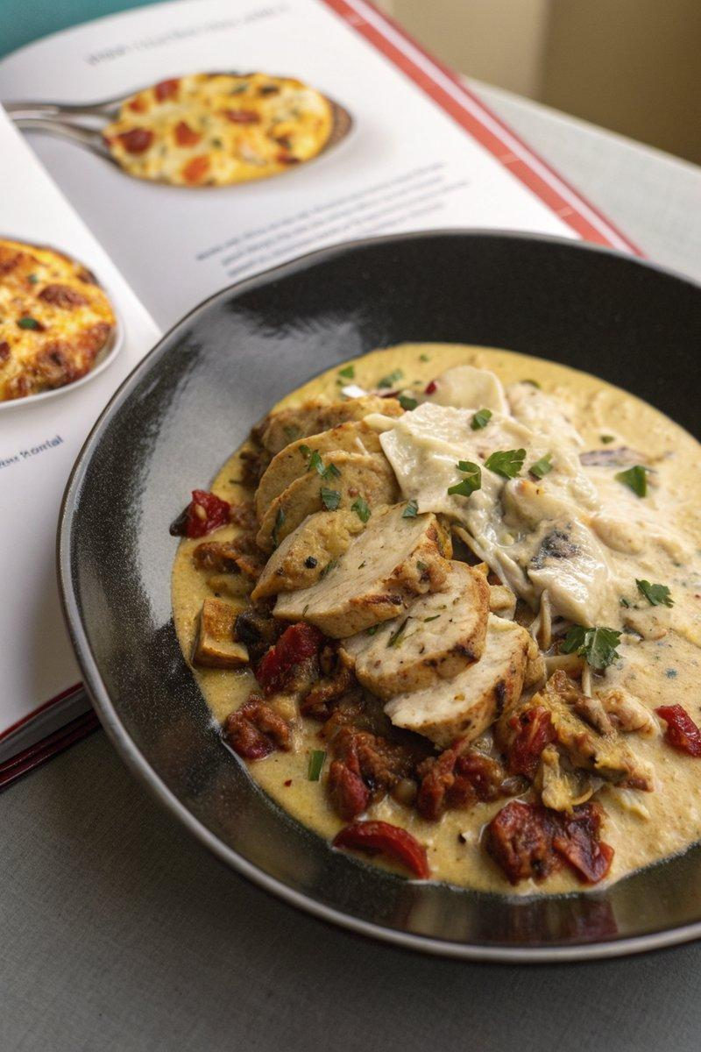

INGREDIENTS  - {'group': 'Main', 'item': '3 skinless, boneless chicken breasts'}  - {'group': 'Sauce', 'item': '2 tbsp tomato purée'}  - {'group': 'Sauce', 'item': '300 ml double cream'}  - {'group': 'Sauce', 'item': '½ garlic bulb, cloves peeled and crushed'}  - {'group': 'Sauce', 'item': '100g sun-dried tomatoes, drained and chopped'}  - {'group': 'Sauce', 'item': '100 ml dry white wine'}  - {'group': 'Sauce', 'item': '100g parmesan, grated'}  - {'group': 'Seasoning', 'item': 'Salt and black pepper'}  - {'group': 'Garnish', 'item': '½ lemon, juiced'}  - {'group': 'Garnish', 'item': 'Small handful of flat-leaf parsley, chopped'} | PREP  Season the chicken breasts with salt and pepper. Crush the garlic cloves and chop the sun-dried tomatoes.  COOK  Place the seasoned chicken breasts in the slow cooker. Add tomato purée, double cream, crushed garlic, chopped sun-dried tomatoes with 1 tbsp of their oil, white wine, and grated parmesan. Mix well, cover, and cook on high for 2-3 hours or on low for 6-7 hours until the chicken is tender.  PLATING  Once cooked, adjust the seasoning with lemon juice and chopped parsley. Serve the chicken breasts whole with the sauce or shred them and mix with the sauce. Top with additional parmesan if desired.

NOTES:
For a side, consider serving with crispy garlic potatoes or roasted new potatoes. To make crispy potatoes, parboil cubed Maris Piper potatoes, then roast in hot oil at 200°C (400°F (200°C)) for 20 minutes, adding minced garlic for the last 5-10 minutes.

