CHICKEN AND CHORIZO SLOW-COOKED ORZO  COOK TIME: 3 hours  SOURCE: Unknown  #chicken #Mediterranean #slow-cook | 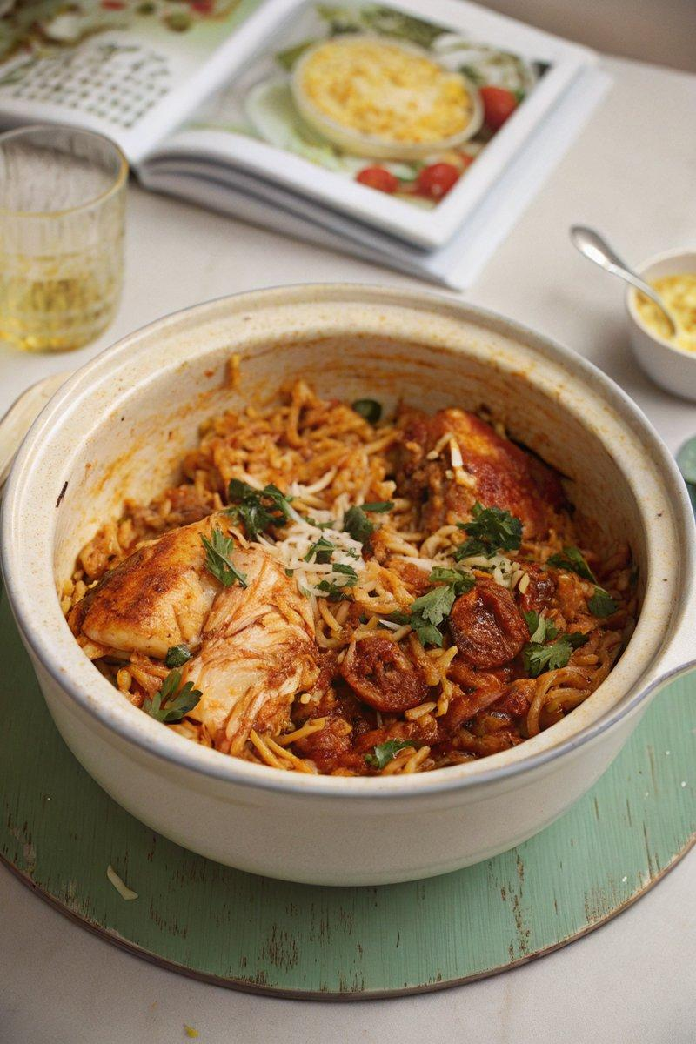

INGREDIENTS  - {'group': 'Main', 'item': '6 skinless, boneless chicken thighs'}  - {'group': 'Main', 'item': '150g cooking chorizo, skin removed and roughly chopped'}  - {'group': 'Sauce', 'item': '2 tbsp tomato purée'}  - {'group': 'Sauce', 'item': '300ml hot chicken stock'}  - {'group': 'Sauce', 'item': '100ml double cream'}  - {'group': 'Sauce', 'item': '2 garlic cloves, grated or crushed'}  - {'group': 'Main', 'item': '250g orzo pasta'}  - {'group': 'Garnish', 'item': '2 large handfuls of baby spinach'}  - {'group': 'Garnish', 'item': 'Handful of flat-leaf parsley, leaves chopped'}  - {'group': 'Garnish', 'item': 'Squeeze of lemon juice'}  - {'group': 'Seasoning', 'item': 'Salt and black pepper'} | PREP  Prepare the chicken by dicing it into bite-sized pieces. Roughly chop the chorizo and grate or crush the garlic cloves.  COOK  In the slow cooker, combine the chicken, chorizo, tomato purée, chicken stock, double cream, and garlic. Season with salt and pepper. Cover and cook on high for 3 hours or on low for 6 hours. Add the orzo and continue cooking for an additional 30-40 minutes on high or 1 hour on low, until the pasta is tender.  PLATING  Stir in the spinach, parsley, and a squeeze of lemon juice. Adjust seasoning to taste and serve hot.

NOTES:
For extra flavour, fry additional chorizo until crispy and serve on top. You can also add chilli flakes for a spicy kick.

