SLOW-COOKED BUFFALO CHICKEN  COOK TIME: 4 hours  SOURCE: Unknown  #chicken #American #slow-cook | 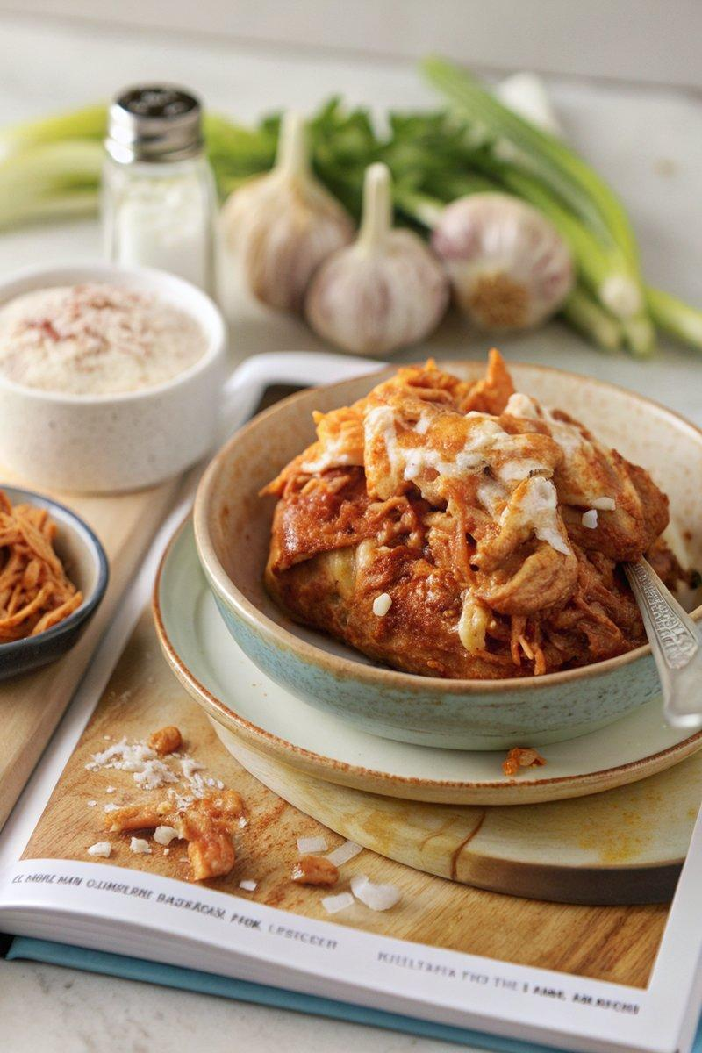

INGREDIENTS  - {'group': 'Main', 'item': '3 skinless, boneless chicken breasts'}  - {'group': 'Sauce', 'item': "148ml Frank's Hot Sauce"}  - {'group': 'Seasoning', 'item': '1 tsp onion salt'}  - {'group': 'Seasoning', 'item': '1 tsp garlic granules'}  - {'group': 'Seasoning', 'item': '1 tbsp light brown soft sugar'} | PREP  Place the chicken breasts in the slow cooker. Add Frank's Hot Sauce, onion salt, garlic granules, and light brown sugar. Mix everything together until the chicken is well coated.  COOK  Cover the slow cooker with the lid and cook on high for 4 hours or on low for 7-8 hours. Once cooked, use kitchen tongs or two forks to shred the chicken into bite-sized pieces.  PLATING  Serve the shredded buffalo chicken in brioche rolls with coleslaw, or use it as a topping for nachos, fries, or baked potatoes. For a cheesy twist, add cream cheese or top with melted cheese.

NOTES:
This buffalo chicken is versatile and can be used in sandwiches, wraps, or as a dip. For a quick baked potato, microwave then air fry or bake in the oven.

