PARMESAN CHICKEN WITH SLOW-COOKED POTATOES  COOK TIME: 4 hours  SOURCE: Unknown  #chicken #Mediterranean #slow-cook | 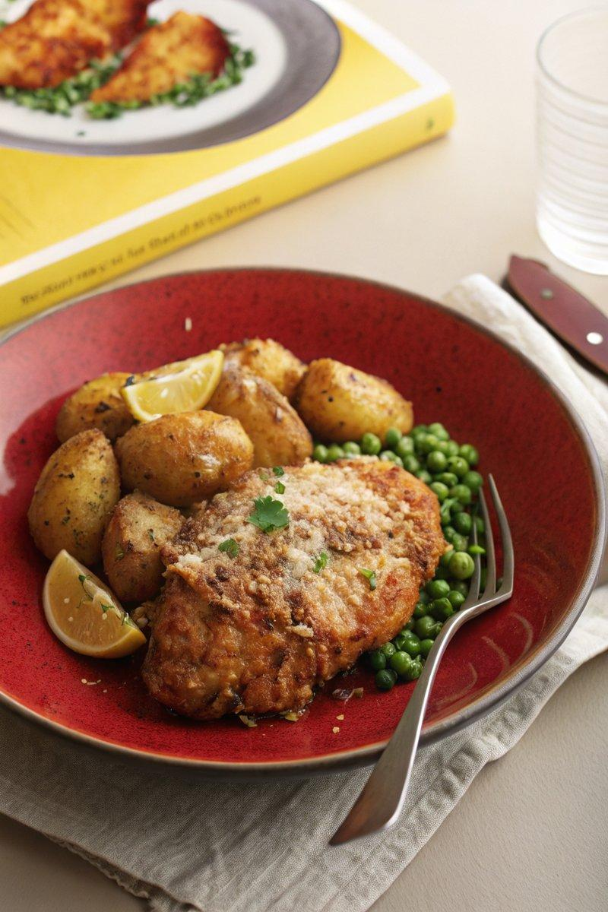

INGREDIENTS  - {'group': 'Main', 'item': '750g baby potatoes'}  - {'group': 'Main', 'item': '3 garlic cloves, grated or crushed'}  - {'group': 'Main', 'item': '1 tbsp dried Italian herbs'}  - {'group': 'Main', 'item': '1 tbsp lemon zest'}  - {'group': 'Main', 'item': '1 tbsp smoked paprika'}  - {'group': 'Main', 'item': '150g parmesan, grated'}  - {'group': 'Main', 'item': '4-6 bone-in, skin-on chicken thighs'}  - {'group': 'Main', 'item': '200ml chicken stock'}  - {'group': 'Main', 'item': '75ml double cream'}  - {'group': 'Main', 'item': '2 tbsp olive oil'}  - {'group': 'Seasoning', 'item': 'Salt and black pepper'} | PREP  Grate the garlic and zest the lemon. Season the chicken thighs with salt and pepper.  COOK  Place the potatoes, garlic, Italian herbs, lemon zest, and smoked paprika in the slow cooker. Season with salt and pepper, then sprinkle half the parmesan over the top. Arrange the chicken thighs on the potatoes. Pour the chicken stock and double cream around the chicken and potatoes, ensuring the chicken is not submerged. Drizzle with olive oil. Cover and cook on high for 4 hours or low for 6-8 hours until the potatoes are tender and the chicken is cooked through.  PLATING  If your slow-cooker bowl is oven-safe, sprinkle the remaining parmesan over the chicken and potatoes, then grill on high for 5-10 minutes until the chicken skin is golden. Alternatively, remove the chicken and fry skin-side down in a pan with a little olive oil until golden. Serve immediately, garnished with the remaining parmesan if fried separately.

NOTES:
For a variation, add crumbled feta or sun-dried tomatoes before serving. Pair with peas tossed with mint for a fresh side.

