SLOW-COOKED CHICKEN TIKKA MASALA  COOK TIME: 4-5 hrs on high or 6-7 hrs on low  SOURCE: Unknown  #chicken #Indian #slow-cook | 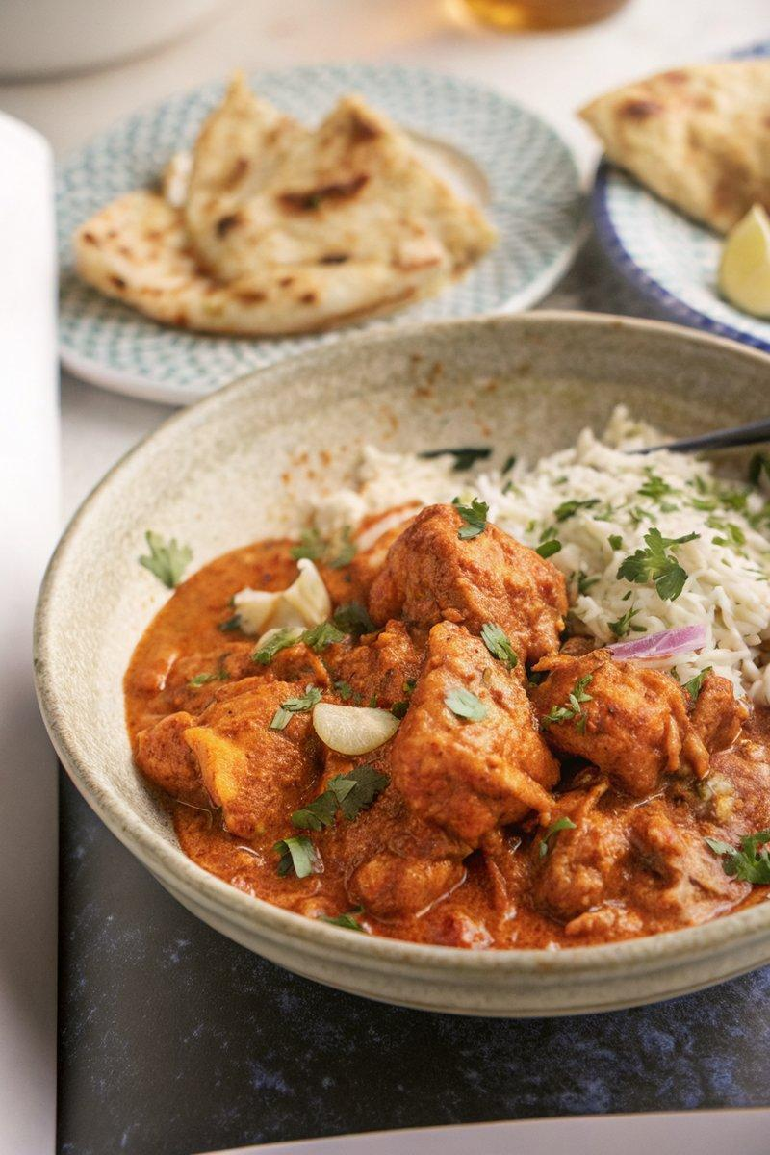

INGREDIENTS  - {'group': 'Main', 'item': '6-8 skinless, boneless chicken thighs'}  - {'group': 'Marinade', 'item': '3 tbsp tikka masala curry paste'}  - {'group': 'Marinade', 'item': '3 garlic cloves, crushed'}  - {'group': 'Marinade', 'item': 'thumb-sized piece of ginger, peeled and finely chopped'}  - {'group': 'Sauce', 'item': '1 tbsp ghee or butter'}  - {'group': 'Sauce', 'item': '1 onion, finely chopped'}  - {'group': 'Sauce', 'item': '2 tbsp tomato purée'}  - {'group': 'Sauce', 'item': '1 tbsp white wine vinegar'}  - {'group': 'Sauce', 'item': '½ tbsp light brown soft sugar'}  - {'group': 'Sauce', 'item': '1 tbsp desiccated coconut'}  - {'group': 'Sauce', 'item': '1 tbsp ground almonds'}  - {'group': 'Sauce', 'item': '1 cinnamon stick or pinch of ground cinnamon'}  - {'group': 'Sauce', 'item': '5 cardamom pods'}  - {'group': 'Sauce', 'item': '300 ml passata'}  - {'group': 'Sauce', 'item': '100 ml coconut cream'}  - {'group': 'Seasoning', 'item': '½ tsp garam masala'}  - {'group': 'Seasoning', 'item': 'squeeze of lemon juice'}  - {'group': 'Seasoning', 'item': 'salt and black pepper'} | PREP  In a mixing bowl, combine the chicken thighs with tikka masala curry paste, crushed garlic, and chopped ginger. Stir well to coat the chicken evenly. Cover and refrigerate for at least 3 hours, or ideally overnight, to marinate.  COOK  Transfer the marinated chicken and its marinade into a slow cooker. Add ghee, chopped onion, tomato purée, white wine vinegar, brown sugar, desiccated coconut, ground almonds, cinnamon, cardamom pods, passata, and coconut cream. Season with salt and pepper. Cover and cook on high for 4-5 hours or on low for 6-7 hours until the chicken is tender. Remove the chicken and blend the sauce until smooth. Return the chicken to the sauce and cook on high for an additional 15 minutes.  PLATING  Serve the chicken tikka masala hot, garnished with a squeeze of lemon juice. Pair with garlic naan and mushroom pilau rice for a complete meal.

NOTES:
For a spicier version, add ½ tbsp of chilli powder to the marinade. Leftovers can be used to make a curry pasty with shortcrust pastry.

