SLOW-COOKED CHICKEN PESTO PASTA  COOK TIME: 3 hrs on high or 7 hrs on low  SOURCE: Unknown  #chicken #Italian #slow-cook | 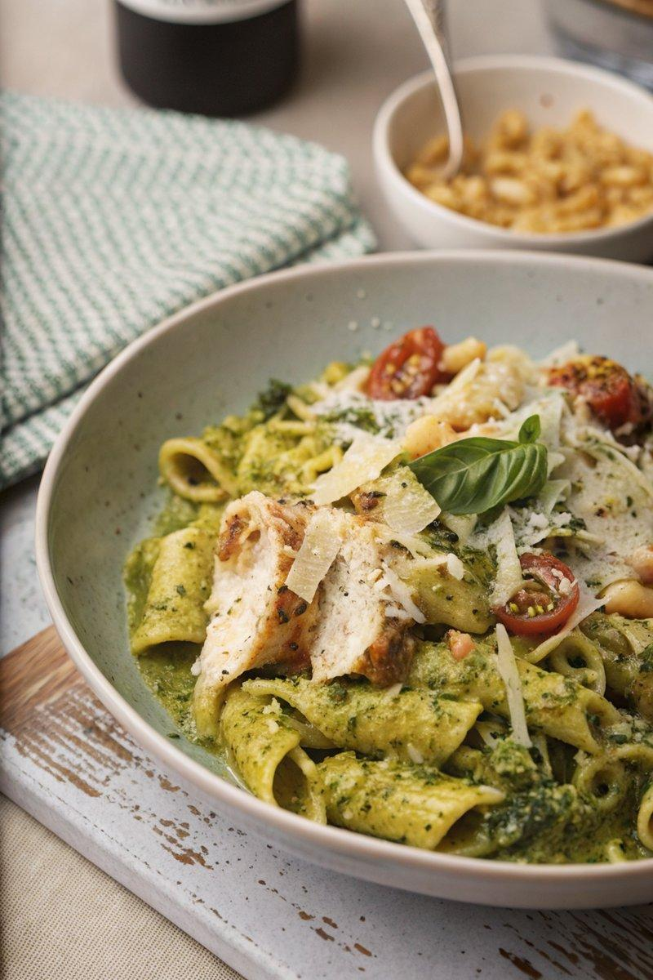

INGREDIENTS  - {'group': 'Main', 'item': '2 skinless, boneless chicken breasts'}  - {'group': 'Main', 'item': '100 ml dry white wine or chicken stock'}  - {'group': 'Main', 'item': '100g parmesan, grated, plus rind if available'}  - {'group': 'Main', 'item': '70g pine nuts, toasted'}  - {'group': 'Main', 'item': '200g mozzarella, torn into pieces'}  - {'group': 'Main', 'item': '3 garlic cloves, minced'}  - {'group': 'Main', 'item': '2 tbsp full-fat cream cheese'}  - {'group': 'Sauce', 'item': '100g basil, plus extra leaves to serve'}  - {'group': 'Sauce', 'item': 'Squeeze of lemon juice'}  - {'group': 'Sauce', 'item': '500 ml hot chicken stock'}  - {'group': 'Main', 'item': '300g rigatoni pasta'}  - {'group': 'Main', 'item': 'Handful of cherry tomatoes, halved'}  - {'group': 'Main', 'item': '3 tbsp olive oil'}  - {'group': 'Seasoning', 'item': 'Salt and black pepper'} | PREP  Season the chicken breasts with salt and pepper. Mince the garlic and toast the pine nuts. Tear the mozzarella into pieces and grate the parmesan.  COOK  Place the chicken breasts in the slow cooker with wine or stock, parmesan, pine nuts, mozzarella, garlic, and cream cheese. Cook on high for 2-3 hours or on low for 6-7 hours. Remove the chicken once cooked. Add basil, lemon juice, and hot chicken stock to the slow cooker and blend until smooth. Stir in the pasta and cook on high for 40 mins to 1 hour until tender. Shred the chicken and return it to the slow cooker with cherry tomatoes and olive oil.  PLATING  Serve the pasta immediately, garnished with extra basil leaves and a sprinkle of grated parmesan. Pair with a side of rocket salad and garlic bread for a complete meal.

NOTES:
For a twist, use red tomato-based pesto instead of basil pesto. Garlic bread can be made in an air fryer or oven for a crispy side.

