SLOW-COOKED BEEF BOURGUIGNON  COOK TIME: 5 hrs  SOURCE: Unknown  #beef #French #slow-cook | 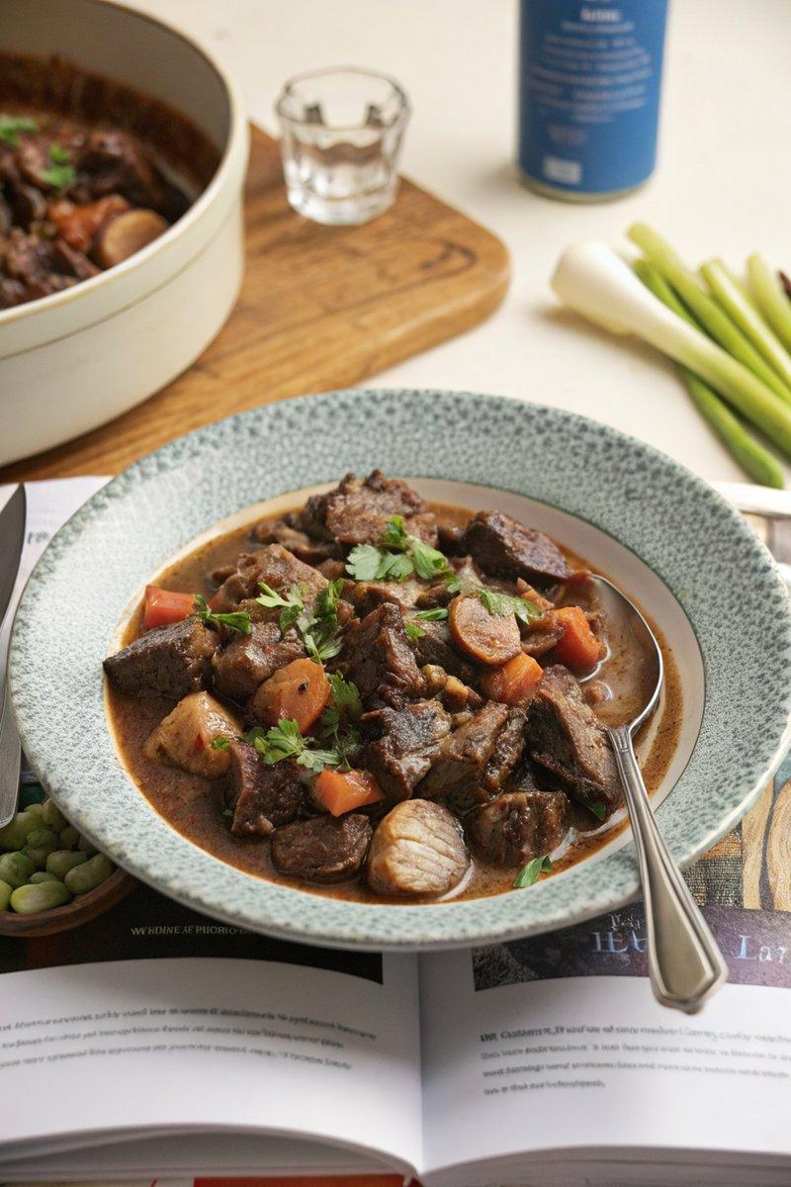

INGREDIENTS  - {'group': 'Main', 'item': '800g beef shin, diced'}  - {'group': 'Main', 'item': '200g pancetta'}  - {'group': 'Main', 'item': '250g shallots, finely diced'}  - {'group': 'Main', 'item': '2 celery sticks, finely diced'}  - {'group': 'Main', 'item': '300g chestnut mushrooms, halved'}  - {'group': 'Main', 'item': '2 carrots, thickly sliced'}  - {'group': 'Main', 'item': 'small handful of thyme, leaves picked'}  - {'group': 'Main', 'item': '2 rosemary sprigs, leaves picked'}  - {'group': 'Main', 'item': '2 bay leaves'}  - {'group': 'Main', 'item': '250ml red wine'}  - {'group': 'Main', 'item': '250ml beef stock'}  - {'group': 'Main', 'item': '30g butter, cubed (optional)'}  - {'group': 'Main', 'item': 'splash of olive oil'}  - {'group': 'Main', 'item': '1 tbsp cornflour, slackened with water'}  - {'group': 'Seasoning', 'item': 'salt and black pepper'}  - {'group': 'Garnish', 'item': 'flat-leaf parsley leaves, to serve (optional)'} | PREP  Season the diced beef shin generously with salt and allow it to reach room temperature. Prepare the cornflour slurry by mixing cornflour with a little water.  COOK  Place the seasoned beef into the slow cooker. Add pancetta, shallots, celery, mushrooms, carrots, thyme, rosemary, bay leaves, red wine, and beef stock. Season with additional salt and black pepper. Cover and cook on high for 5 hours until the beef is tender and shreds easily. Stir in the cornflour slurry to thicken the sauce.  PLATING  Serve the beef bourguignon hot, garnished with flat-leaf parsley. Pair with mashed potatoes or crusty bread for a complete meal.

NOTES:
For an extra flavour boost, consider adding a spoonful of Dijon mustard before cooking. This dish is perfect for a cozy winter evening.

