INDONESIAN BEEF RENDANG  COOK TIME: 5 hrs on high or 8-10 hrs on low  SOURCE: Unknown  #beef #Asian #slow-cook | 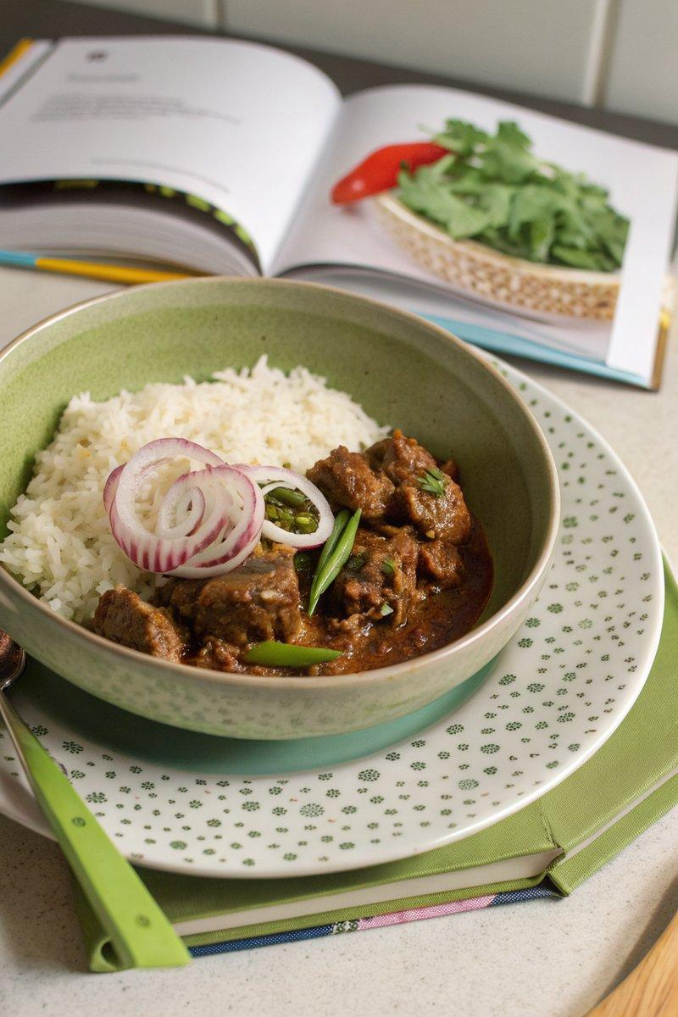

INGREDIENTS  - {'group': 'Main', 'item': '800g beef shin, diced'}  - {'group': 'Main', 'item': '1 red onion, finely diced'}  - {'group': 'Main', 'item': '1 lemongrass stick, bruised'}  - {'group': 'Main', 'item': '400ml full-fat coconut milk'}  - {'group': 'Main', 'item': '2 long green chillies, split lengthways'}  - {'group': 'Main', 'item': '1 beef or chicken stock cube, dissolved in 200ml boiling water'}  - {'group': 'Main', 'item': '2-3 tbsp rendang paste'}  - {'group': 'Main', 'item': '1 tbsp tamarind paste'}  - {'group': 'Main', 'item': '1 tbsp coconut or dark brown soft sugar'}  - {'group': 'Main', 'item': '1 cinnamon stick'}  - {'group': 'Main', 'item': '1 star anise'}  - {'group': 'Main', 'item': '2 cardamom pods, bashed'}  - {'group': 'Main', 'item': '3 cloves'}  - {'group': 'Main', 'item': '50g desiccated coconut'}  - {'group': 'Main', 'item': '1 tbsp cornflour, slackened with water'}  - {'group': 'Seasoning', 'item': 'Salt and black pepper'} | PREP  Season the diced beef shin generously with salt and allow it to come to room temperature. Finely dice the red onion and bruise the lemongrass stick. Dissolve the stock cube in boiling water.  COOK  Place the beef, onion, lemongrass, coconut milk, chillies, stock, rendang paste, tamarind paste, sugar, cinnamon stick, star anise, cardamom pods, and cloves into the slow cooker. Stir to combine, then cover and cook on high for 5 hours or on low for 8-10 hours, until the beef is tender and shreds easily. Stir in the desiccated coconut and cornflour slurry, adjusting seasoning with salt and pepper as needed.  PLATING  Serve the beef rendang hot with steamed rice, garnished with extra chillies if desired, and lime wedges on the side for squeezing.

NOTES:
For a homemade rendang paste, blend 2 deseeded red chillies, 1 peeled shallot, a thumb-sized piece of peeled ginger or galangal, 2 peeled garlic cloves, 1 bruised lemongrass stick, 2 makrut lime leaves, 1 tbsp cumin seeds, and 1 tbsp coriander seeds into a coarse paste. Store in the fridge for up to a week or freeze for longer storage.

