CLASSIC BEEF STEW  COOK TIME: 5 hrs  SOURCE: Unknown  #beef #American #slow-cook | 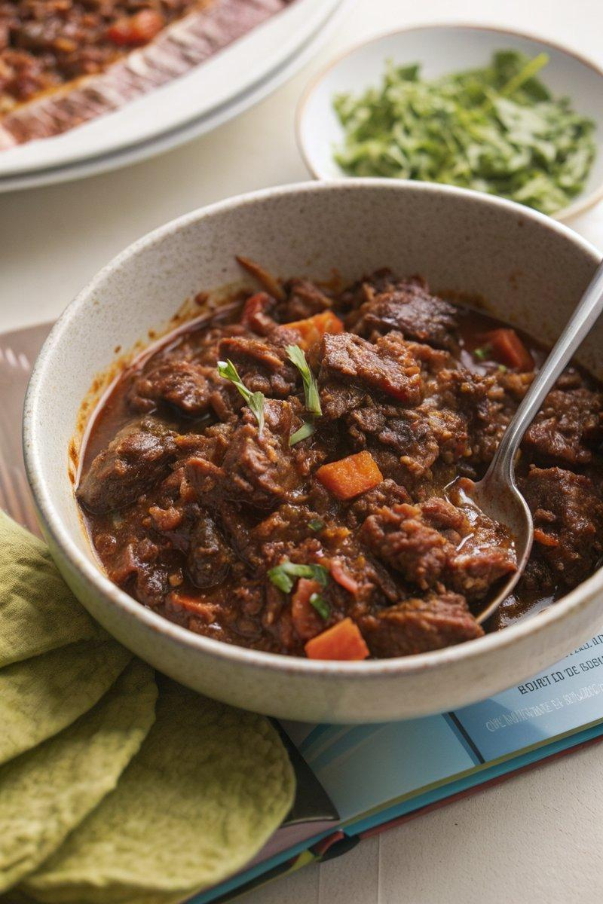

INGREDIENTS  - {'group': 'Main', 'item': '800g beef short rib, diced'}  - {'group': 'Main', 'item': '200g smoked bacon lardons or diced pancetta'}  - {'group': 'Main', 'item': '2 celery sticks, cut into 2-3cm pieces'}  - {'group': 'Main', 'item': '2 carrots, cut into 2-3cm dice'}  - {'group': 'Main', 'item': '6 shallots, peeled and halved if large'}  - {'group': 'Main', 'item': '2 bay leaves'}  - {'group': 'Main', 'item': 'small handful of thyme leaves, picked'}  - {'group': 'Main', 'item': '2 rosemary sprigs, leaves picked'}  - {'group': 'Main', 'item': '4 garlic cloves, thinly sliced'}  - {'group': 'Main', 'item': '1-2 tbsp tomato purée'}  - {'group': 'Main', 'item': '500ml beef stock'}  - {'group': 'Main', 'item': '500ml ale'}  - {'group': 'Main', 'item': '1-2 tsp Dijon or wholegrain mustard'}  - {'group': 'Main', 'item': '8 waxy potatoes, cut into 2-3cm dice'}  - {'group': 'Main', 'item': '1 tbsp cornflour, slackened with water (optional)'}  - {'group': 'Seasoning', 'item': 'salt and black pepper'} | PREP  Season the diced beef short rib generously with salt and allow it to come to room temperature. Prepare the vegetables by cutting the celery and carrots into 2-3cm pieces, peeling and halving the shallots if large, and slicing the garlic thinly. Pick the leaves from the thyme and rosemary sprigs.  COOK  In the slow cooker, combine the seasoned beef, bacon lardons, celery, carrots, shallots, bay leaves, thyme, rosemary, garlic, tomato purée, beef stock, ale, mustard, and a teaspoon of salt with plenty of black pepper. Cover and cook on high for 5 hours. After the first hour, add the diced potatoes. If desired, stir in the cornflour slurry towards the end to thicken the stew. Adjust seasoning with additional salt, pepper, and mustard to taste.  PLATING  Serve the beef stew hot with crusty bread or your choice of steamed green vegetables.

NOTES:
For a non-alcoholic version, replace the ale with additional beef stock and a spoonful of yeast extract for depth of flavour.

