SLOW-COOKED CHIPOTLE BEEF TACOS  COOK TIME: 4-5 hrs on high or 8-10 hrs on low  SOURCE: Unknown  #beef #Mexican #slow-cook | 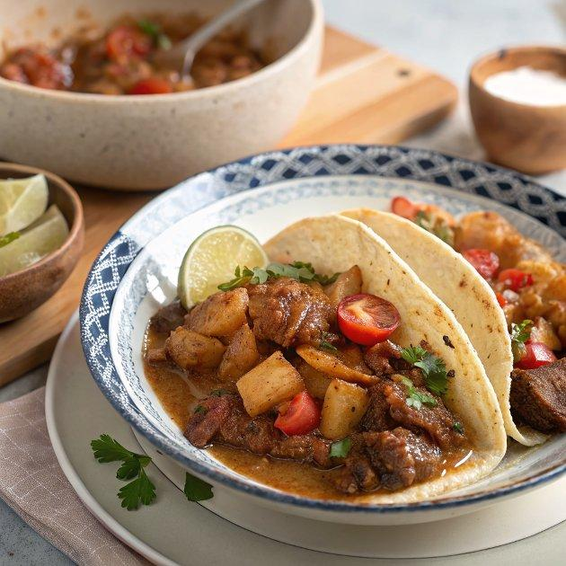

INGREDIENTS  - {'group': 'Main', 'item': '700g beef shin or braising beef, diced'}  - {'group': 'Main', 'item': '100g chipotle paste'}  - {'group': 'Main', 'item': '1 onion, sliced'}  - {'group': 'Main', 'item': '3 garlic cloves, chopped'}  - {'group': 'Main', 'item': '2 large tomatoes, quartered'}  - {'group': 'Main', 'item': '2 thyme sprigs'}  - {'group': 'Main', 'item': '200ml beef stock'}  - {'group': 'For Serving', 'item': '8 small corn tacos'}  - {'group': 'Seasoning', 'item': 'Salt and black pepper'} | PREP  In a bowl, combine the diced beef shin with chipotle paste. Cover and let it marinate at room temperature for 30 minutes.  COOK  Transfer the marinated beef, sliced onion, chopped garlic, quartered tomatoes, thyme sprigs, and beef stock to a slow cooker. Season with salt and pepper. Cook on high for 4-5 hours or on low for 8-10 hours until the beef is tender. Once cooked, remove the thyme sprigs and shred the beef slightly using tongs or a fork. Drain the cooking liquid into a saucepan and bring to a boil on the stovetop, reducing it by half.  PLATING  Return the shredded beef to the reduced sauce, stirring to combine. Serve the beef mixture in warm corn tacos.

NOTES:
For a complete meal, serve with guacamole made from avocado, red onion, lime, chilli, and coriander. Pico de gallo also pairs well with these tacos.

