PORK SAUSAGES IN YORKSHIRE PUDDING WITH RED ONION GRAVY  COOK TIME: 50 mins  SOURCE: Unknown  #pork #British #bake | 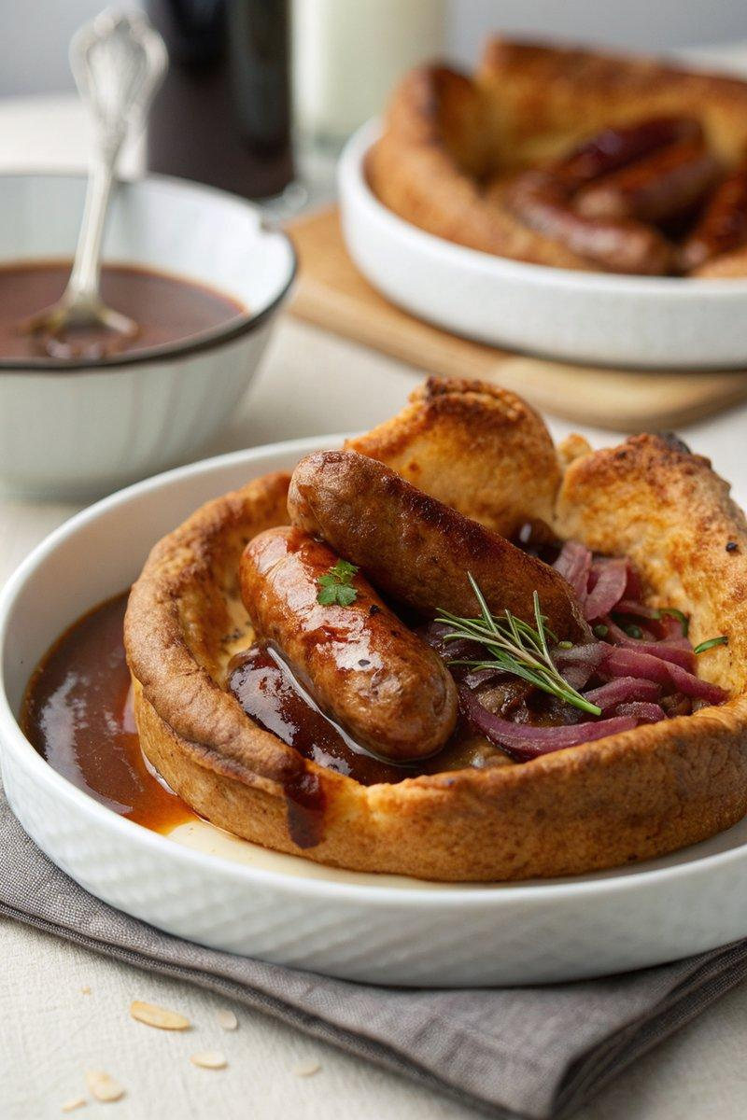

INGREDIENTS  - {'group': 'Main', 'item': '140g plain flour'}  - {'group': 'Main', 'item': '4 medium eggs'}  - {'group': 'Main', 'item': '200ml semi-skimmed milk'}  - {'group': 'Main', 'item': '8 thick pork sausages'}  - {'group': 'Main', 'item': '2 tbsp sunflower oil'}  - {'group': 'Main', 'item': '1/4 tsp salt'}  - {'group': 'Main', 'item': '1/4 tsp ground black pepper'}  - {'group': 'Gravy', 'item': '1 tbsp sunflower oil'}  - {'group': 'Gravy', 'item': '1 tbsp unsalted butter'}  - {'group': 'Gravy', 'item': '2 large red onions, thinly sliced'}  - {'group': 'Gravy', 'item': '2 tsp light brown sugar'}  - {'group': 'Gravy', 'item': '2 tbsp plain flour'}  - {'group': 'Gravy', 'item': '480ml hot beef stock'}  - {'group': 'Gravy', 'item': '1 tsp Worcestershire sauce'}  - {'group': 'Gravy', 'item': '1/4 tsp salt'}  - {'group': 'Gravy', 'item': '1/4 tsp ground black pepper'}  - {'group': 'Garnish', 'item': '10 sprigs of thyme (optional)'} | PREP  In a large bowl, combine 140g of plain flour with 4 medium eggs, mixing gradually with a whisk. Slowly incorporate 200ml of semi-skimmed milk until the batter is smooth. Chill the batter in the fridge for at least 1 hour.  COOK  Preheat the oven to 220°C (425°F (220°C)). Arrange 8 pork sausages in a large baking dish and drizzle with 2 tbsp of sunflower oil. Bake for 15-20 mins, turning occasionally, until browned. Remove the batter from the fridge, season with salt and pepper, and pour around the sausages. Bake for 25-35 mins until the Yorkshire pudding is golden and risen. Meanwhile, heat 1 tbsp of sunflower oil and 1 tbsp of butter in a pan. Add 2 sliced red onions and 2 tsp of sugar, cooking on medium-low for 15-20 mins until caramelized. Stir in 2 tbsp of flour, cook for 2 mins, then gradually add 480ml (2 cups) of hot beef stock, whisking until thickened. Season with Worcestershire sauce, salt, and pepper.  PLATING  Serve the sausages and Yorkshire pudding hot, topped with the red onion gravy. Garnish with fresh thyme sprigs if desired. Pair with peas and cabbage for a complete meal.

NOTES:
Ensure the batter is cold before pouring it into the hot dish for the best rise. Use a metal or enamel dish for even heat distribution.

