SLOW-COOKED BEEF WITH ONION AND GARLIC  COOK TIME: 3 hrs  SOURCE: Unknown  #beef #American #slow-cook | 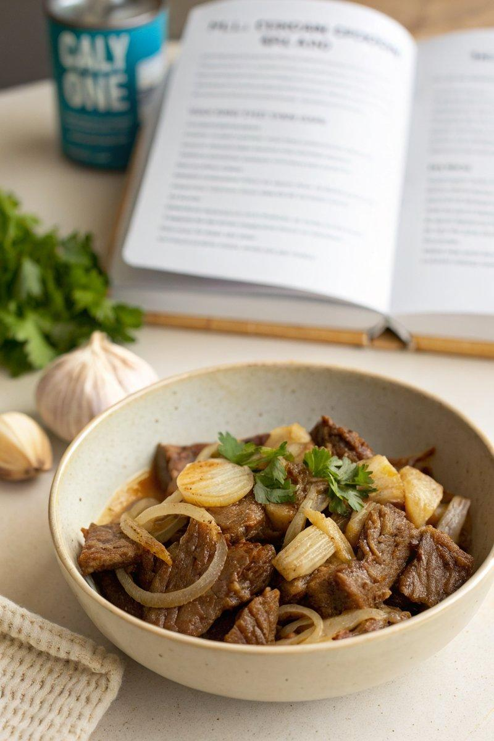

INGREDIENTS  - {'group': 'Main', 'item': '1 kg beef chuck, cut into large pieces'} | PREP  Slice the onions and mince the garlic. Cut the beef chuck into large pieces, trimming any excess fat.  COOK  Season the beef pieces with salt and pepper. In a slow cooker, layer the sliced onions and minced garlic at the bottom. Place the seasoned beef on top. Cover and cook on low for 6-8 hours, or until the beef is tender and easily pulls apart with a fork.  PLATING  Serve the slow-cooked beef with its juices over mashed potatoes or alongside steamed vegetables for a complete meal.

NOTES:
For added flavour, consider browning the beef in a hot pan before adding it to the slow cooker.

