SLOW-COOKED BEEF WITH ONION AND TOMATO  COOK TIME: 2 hrs  SOURCE: Unknown  #beef #Mediterranean #slow-cook | 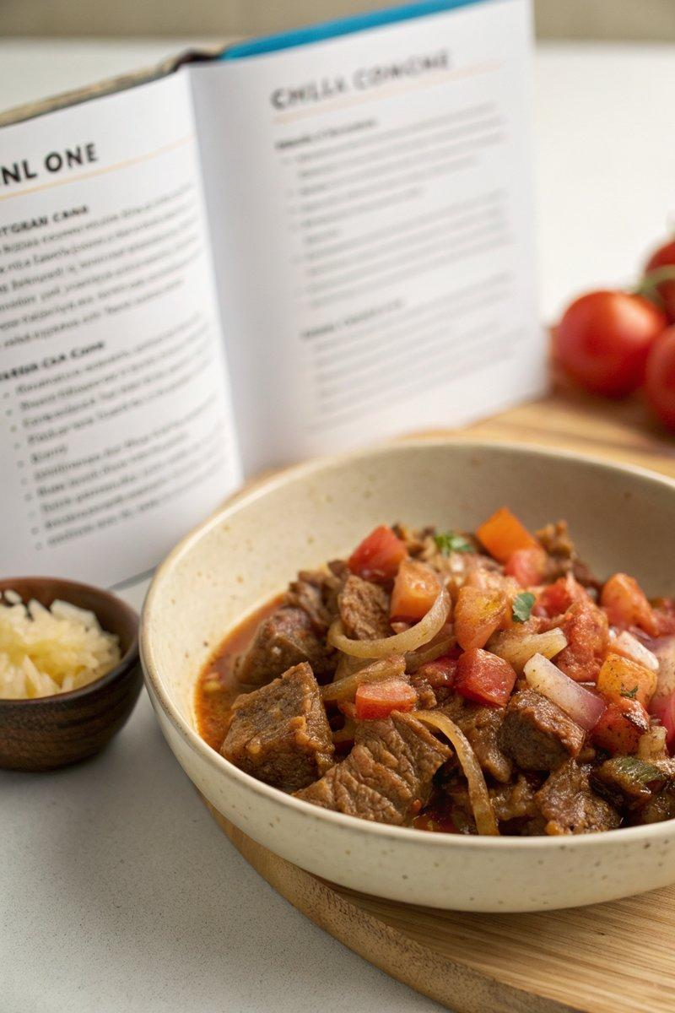

INGREDIENTS  - {'group': 'Main', 'item': '1 kg beef chuck, cut into cubes'} | PREP  Slice the onions and chop the tomatoes. Mince the garlic. Cut the beef chuck into cubes.  COOK  Heat olive oil in a dutch oven over medium heat. Add the beef cubes and sear until browned on all sides, about 5 mins. Remove the beef and set aside. In the same pot, add the onions and garlic, sautéing until the onions are translucent. Return the beef to the pot, add the tomatoes, and season with salt and pepper. Cover and reduce the heat to low, allowing the mixture to simmer for 2 hrs, stirring occasionally, until the beef is tender.  PLATING  Serve the beef hot, garnished with fresh herbs if desired, alongside crusty bread or mashed potatoes.

NOTES:
For a deeper flavour, consider adding a splash of red wine during the cooking process.

