QUICK CHICKEN STIR-FRY WITH SWEET AND SPICY SAUCE  COOK TIME: 15 mins  SOURCE: Unknown  #chicken #asian #stir-fry | 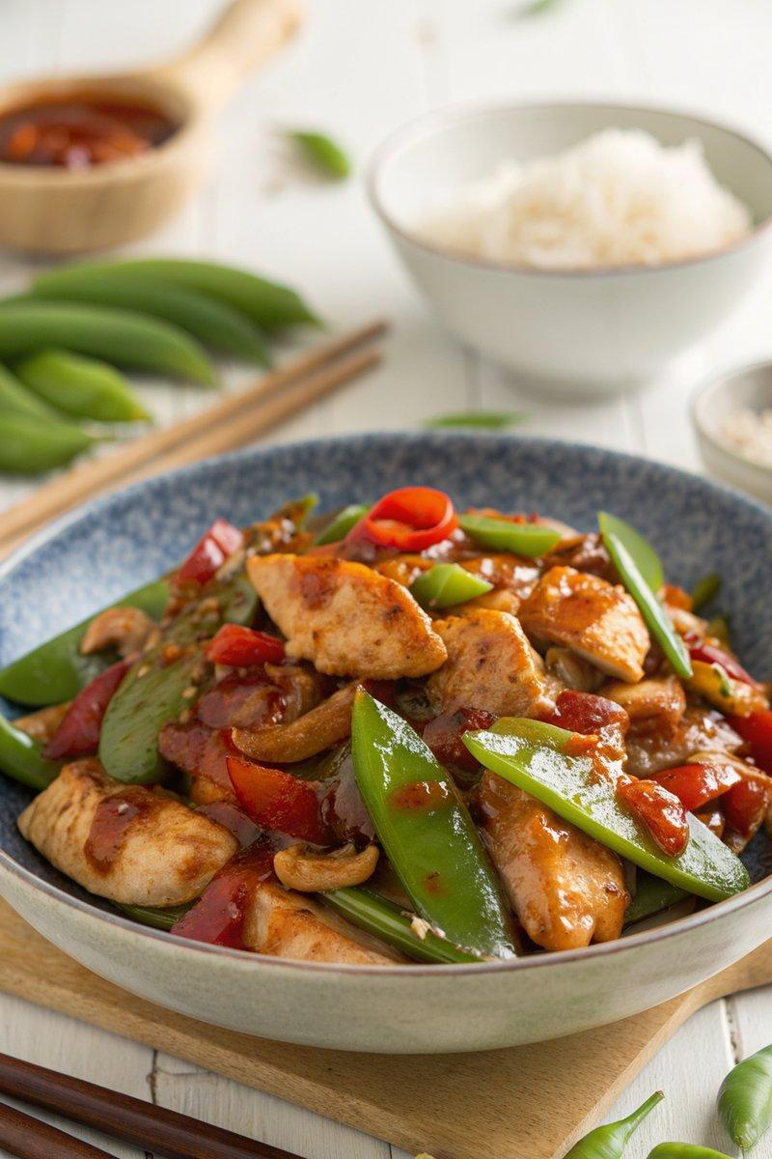

INGREDIENTS  - {'group': 'Main', 'item': '600g chicken breasts, sliced into bite-size pieces'}  - {'group': 'Main', 'item': '2 tbsp cornflour'}  - {'group': 'Main', 'item': 'Pinch of salt and pepper'}  - {'group': 'Main', 'item': '2 tbsp sunflower oil'}  - {'group': 'Main', 'item': '20 sugar snap peas'}  - {'group': 'Main', 'item': '1 yellow bell pepper, sliced'}  - {'group': 'Main', 'item': '1 red bell pepper, sliced'}  - {'group': 'Sauce', 'item': '2 garlic cloves, minced'}  - {'group': 'Sauce', 'item': '4 tbsp soy sauce'}  - {'group': 'Sauce', 'item': '2 tbsp Chinese rice vinegar'}  - {'group': 'Sauce', 'item': '3 tbsp brown sugar'}  - {'group': 'Sauce', 'item': '3 tbsp sweet chilli sauce'}  - {'group': 'Sauce', 'item': '2 tbsp tomato ketchup'}  - {'group': 'Garnish', 'item': 'A bunch of spring onions, chopped'}  - {'group': 'Garnish', 'item': '1 small red chilli, sliced'} | PREP  Slice the chicken breasts into bite-size pieces. In a bowl, toss the chicken with cornflour, salt, and pepper until evenly coated. Prepare the vegetables by slicing the bell peppers and chopping the spring onions.  COOK  Heat the sunflower oil in a wok over high heat. Add the chicken and stir-fry for 5-6 mins until lightly browned. Add the sugar snap peas and bell peppers, cooking for an additional 2 mins. Stir in the garlic, soy sauce, rice vinegar, brown sugar, sweet chilli sauce, and tomato ketchup. Toss everything together and cook until the chicken is fully cooked and the sauce is heated through.  PLATING  Serve the stir-fry over cooked rice or noodles. Garnish with chopped spring onions and sliced red chilli for added freshness and heat.

NOTES:
For a variation, consider adding pineapple chunks for a sweet and sour twist.

