SLOW-COOKED ROAST LAMB WITH POTATOES  COOK TIME: 5 hrs 30 mins  SOURCE: Unknown  #lamb #Mediterranean #slow-cook | 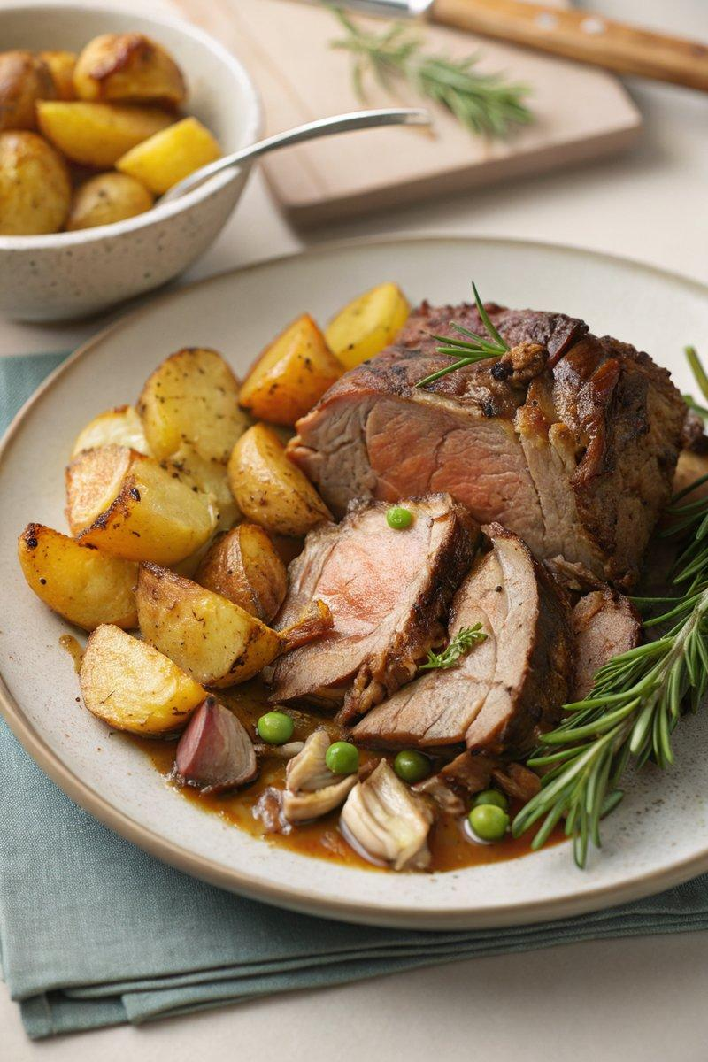

INGREDIENTS  - {'group': 'Main', 'item': '1.2kg bone-in lamb leg'}  - {'group': 'Main', 'item': '9 garlic cloves, peeled'}  - {'group': 'Main', 'item': '3 rosemary sprigs, each cut into thirds'}  - {'group': 'Main', 'item': 'olive oil, for rubbing and drizzling'}  - {'group': 'Main', 'item': '4 King Edward potatoes, peeled and quartered'}  - {'group': 'Main', 'item': '1 red onion, thinly sliced'}  - {'group': 'Main', 'item': '3 thyme sprigs'}  - {'group': 'Garnish', 'item': 'small handful of mint leaves, chopped'}  - {'group': 'Seasoning', 'item': 'salt and black pepper'}  - {'group': 'Optional', 'item': '2 tinned anchovies, drained'}  - {'group': 'Optional', 'item': '1 tbsp capers'} | PREP  Using a sharp knife, make 9 deep cuts into the lamb leg. Insert a garlic clove and a third of a rosemary sprig into each cut. Rub the lamb with olive oil and season generously with salt and pepper.  COOK  Place the potatoes, red onion, thyme, anchovies, and capers (if using) in the slow cooker. Set the seasoned lamb leg on top. Cover and cook on high for 5 hours or on low for 8 hours, until the lamb is tender and the potatoes are cooked. Preheat the oven to 220°C (200°C (400°F (200°C)) fan). Transfer the lamb and potatoes to a roasting tin, drizzle with olive oil, and roast for 25-30 minutes until golden and crispy.  PLATING  Strain the cooking juices from the slow cooker into a jug. Stir in the chopped mint leaves. Carve the lamb and serve with the roasted potatoes, drizzling the mint sauce over the top.

NOTES:
For a complete meal, serve with minted peas and cumin-glazed carrots. Leftover lamb can be used in sandwiches with additional mint sauce.

