SLOW-COOKED LAMB RAGU WITH PAPPARDELLE  COOK TIME: 4 hrs on high or 7 hrs on low  SOURCE: Unknown  #lamb #Italian #slow-cook | 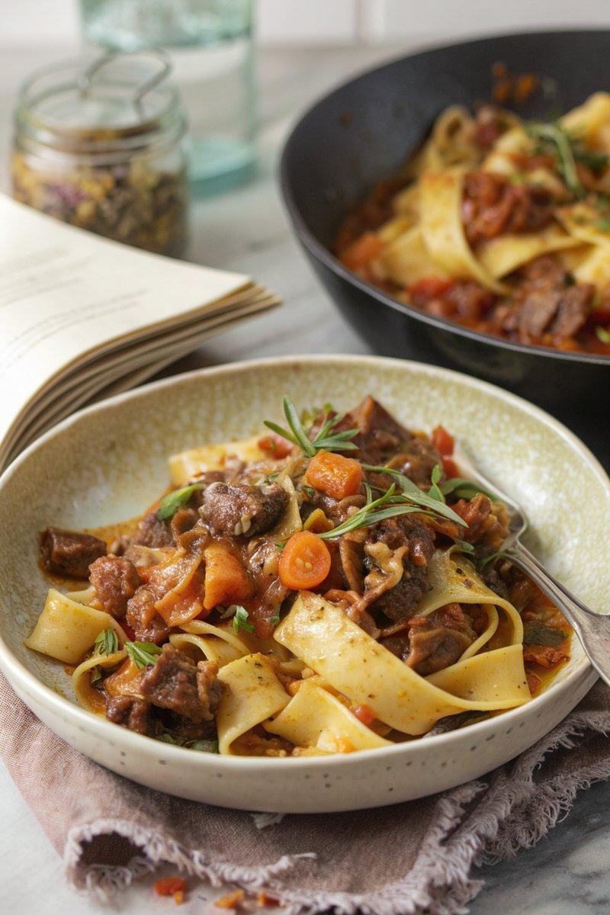

INGREDIENTS  - {'group': 'Main', 'item': '65g diced smoked pancetta'}  - {'group': 'Main', 'item': '300g lamb shoulder, diced'}  - {'group': 'Main', 'item': '1 onion, grated'}  - {'group': 'Main', 'item': '2 carrots, peeled and grated'}  - {'group': 'Main', 'item': '2 celery sticks, finely chopped'}  - {'group': 'Main', 'item': '4 garlic cloves, minced'}  - {'group': 'Main', 'item': '3 rosemary sprigs'}  - {'group': 'Sauce', 'item': '1 tbsp tomato purée'}  - {'group': 'Sauce', 'item': '200ml red wine'}  - {'group': 'Sauce', 'item': '200ml passata'}  - {'group': 'Sauce', 'item': '100ml lamb stock'}  - {'group': 'Seasoning', 'item': 'Salt and black pepper'}  - {'group': 'For Serving', 'item': '300-450g pappardelle, cooked to packet instructions'}  - {'group': 'Garnish', 'item': 'Grated parmesan'} | PREP  Grate the onion and carrots, finely chop the celery, and mince the garlic. Dice the lamb shoulder and pancetta.  COOK  In a frying pan over medium heat, cook the pancetta until golden and its fat is rendered. Transfer to a slow cooker. Add the lamb, onion, carrots, celery, garlic, rosemary, tomato purée, red wine, passata, and lamb stock to the slow cooker. Season with salt and pepper. Cover and cook on high for 4 hours or on low for 7 hours, until the lamb is tender and falling apart. If the sauce needs thickening, transfer to a saucepan and simmer over medium-high heat until reduced to your liking.  PLATING  Toss the ragu with cooked pappardelle and serve in bowls. Generously sprinkle with grated parmesan before serving.

NOTES:
This dish freezes well, making it perfect for meal prep. Simply reheat and serve with freshly cooked pasta. Ensure plenty of parmesan for serving.

