SLOW-COOKED LAMB SHANKS WITH RED WINE SAUCE  COOK TIME: 6-7 hrs on high or 8-10 hrs on low  SOURCE: Unknown  #lamb #Mediterranean #slow-cook | 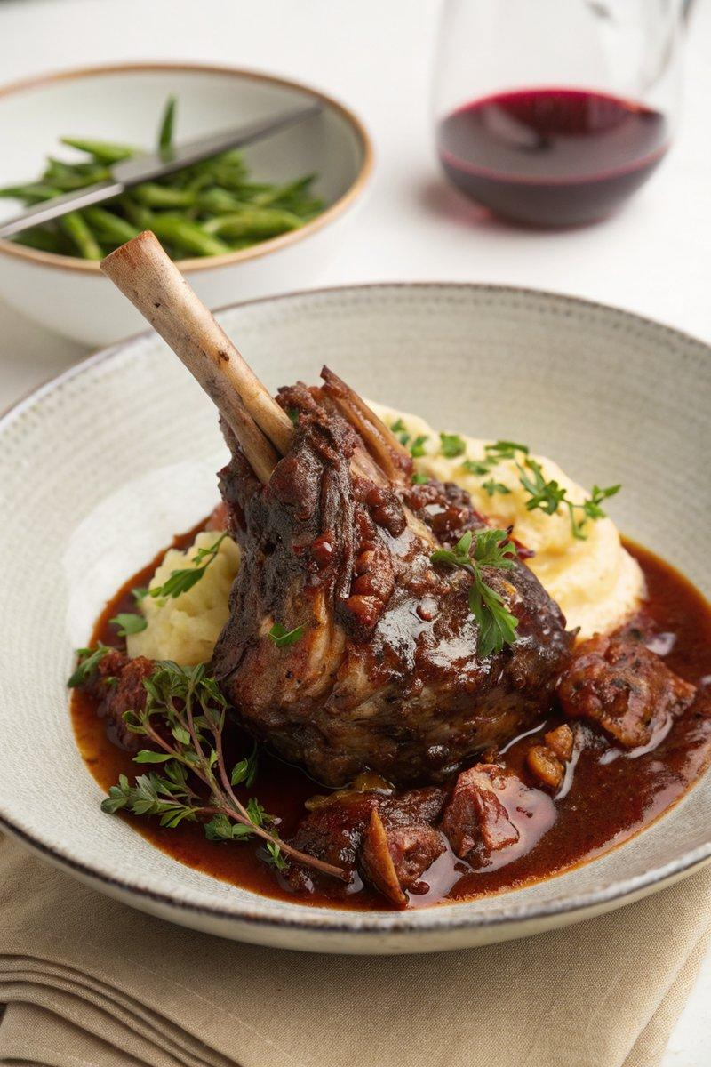

INGREDIENTS  - {'group': 'Main', 'item': '2 bone-in lamb shanks (each about 200g)'}  - {'group': 'Main', 'item': '200ml red wine (Malbec preferred)'}  - {'group': 'Main', 'item': '400ml lamb stock'}  - {'group': 'Main', 'item': '1 star anise'}  - {'group': 'Main', 'item': '1 red onion, grated'}  - {'group': 'Main', 'item': '1 carrot, grated'}  - {'group': 'Main', 'item': '2 garlic cloves, finely chopped'}  - {'group': 'Main', 'item': '1 tbsp tomato purée'}  - {'group': 'Main', 'item': '1 tsp Worcestershire sauce'}  - {'group': 'Seasoning', 'item': 'Salt and black pepper'} | PREP  Season the lamb shanks generously with salt and black pepper. Grate the red onion and carrot, and finely chop the garlic.  COOK  Place the seasoned lamb shanks, red wine, lamb stock, star anise, grated onion, grated carrot, chopped garlic, tomato purée, and Worcestershire sauce into the slow cooker. Mix well, cover, and cook on high for 6-7 hours or on low for 8-10 hours until the meat is tender and falls off the bone. Remove the shanks and set aside. Transfer the cooking juices to a saucepan, discard the star anise, and boil over medium-high heat until reduced by half to a gravy-like consistency.  PLATING  Serve the lamb shanks drizzled with the reduced sauce. Pair with creamy mashed potatoes and garlicky green beans for a complete meal.

NOTES:
For the green beans, boil them in salted water for 4-6 minutes, then toss with 3 grated garlic cloves warmed in 50g of salted butter.

