LAMB SHEPHERD'S PIE WITH MASHED POTATO TOPPING  COOK TIME: 4 hrs 15 mins  SOURCE: Unknown  #lamb #British #bake | 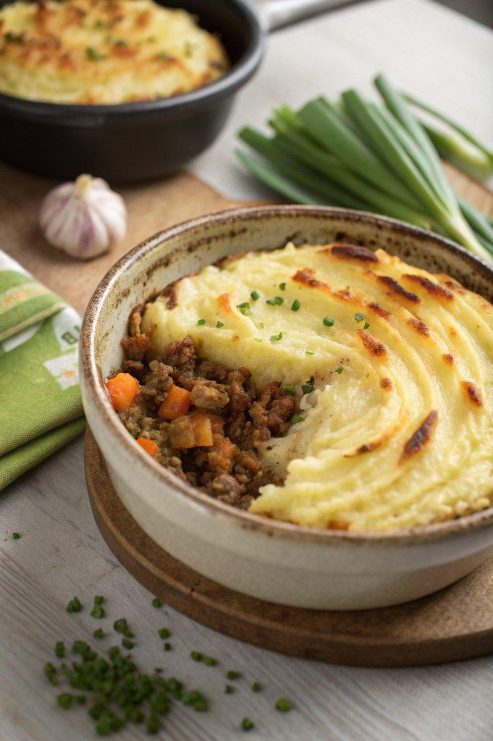

INGREDIENTS  - {'group': 'Main', 'item': '750g lamb mince'}  - {'group': 'Main', 'item': '1 onion, finely diced'}  - {'group': 'Main', 'item': '2 carrots, scrubbed and finely diced'}  - {'group': 'Main', 'item': '2 celery sticks, finely diced'}  - {'group': 'Main', 'item': '4 garlic cloves, grated or crushed'}  - {'group': 'Main', 'item': '1 rosemary sprig, leaves picked'}  - {'group': 'Main', 'item': '300ml lamb stock'}  - {'group': 'Main', 'item': '1 tbsp Worcestershire sauce, plus extra to taste'}  - {'group': 'Main', 'item': '30g butter, cubed (optional)'}  - {'group': 'Main', 'item': 'splash of olive oil'}  - {'group': 'Main', 'item': '1 tbsp cornflour slackened with water (optional)'}  - {'group': 'Main', 'item': 'salt and black pepper'}  - {'group': 'Topping', 'item': '700g Maris Piper potatoes, peeled and cut into 2cm slices'}  - {'group': 'Topping', 'item': '50g butter, cubed'}  - {'group': 'Topping', 'item': '100ml whole milk'} | PREP  Peel and slice the potatoes into 2cm pieces. Finely dice the onion, carrots, and celery. Grate or crush the garlic cloves. Pick the rosemary leaves from the sprig.  COOK  Combine the lamb mince, onion, carrots, celery, garlic, rosemary, lamb stock, Worcestershire sauce, butter (if using), olive oil, salt, and pepper in a slow cooker. Stir well, cover, and cook on high for 4 hours until the lamb is tender. Meanwhile, boil the potatoes in salted water for 15-20 minutes until tender. Drain and mash them with butter and milk until smooth, seasoning with salt. Once the filling is ready, stir in the cornflour mixture if using, and adjust seasoning with salt, pepper, and extra Worcestershire sauce to taste.  PLATING  Preheat the oven or grill to high. Spoon the mashed potatoes over the lamb filling in an ovenproof dish. Bake or grill for 10-15 minutes until the top is golden and crisp. Serve hot with buttery peas and roasted carrots on the side.

NOTES:
No additional notes

