SLOW-COOKED PULLED PORK  COOK TIME: 5 hrs on high or 8-10 hrs on low  SOURCE: Unknown  #pork #American #slow-cook | 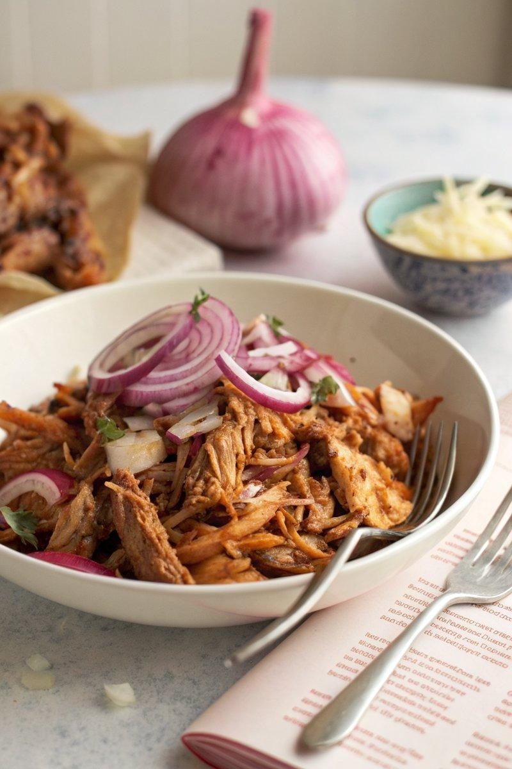

INGREDIENTS  - {'group': 'Main', 'item': '800g boneless pork shoulder'}  - {'group': 'Main', 'item': '1 red onion, thinly sliced'}  - {'group': 'Main', 'item': '½ garlic bulb, cloves separated, peeled and grated'}  - {'group': 'Main', 'item': '400g can of plum tomatoes, crushed'}  - {'group': 'Main', 'item': '2 tbsp tomato purée'}  - {'group': 'Main', 'item': '1 tbsp dark brown soft sugar'}  - {'group': 'Main', 'item': '1 tsp cumin seeds'}  - {'group': 'Main', 'item': '2 bay leaves'}  - {'group': 'Main', 'item': '1 heaped tsp smoked paprika'}  - {'group': 'Main', 'item': '300ml lager'}  - {'group': 'Main', 'item': '1-2 tsp chili flakes, to taste'}  - {'group': 'Seasoning', 'item': 'Salt and black pepper'} | PREP  Season the pork shoulder generously with salt and let it come to room temperature. Trim any large pieces of fat, but leave some for flavour.  COOK  Place the pork shoulder, red onion, garlic, crushed plum tomatoes, tomato purée, dark brown sugar, cumin seeds, bay leaves, smoked paprika, lager, chili flakes, and 1 tsp each of salt and pepper into the slow cooker. Stir to combine. Cover and cook on high for 5 hours or on low for 8-10 hours until the pork is tender. Remove the skin and shred the pork with a fork. Mix the shredded pork back into the sauce and adjust seasoning to taste.  PLATING  Serve the pulled pork hot, either on sandwiches, burgers, or over fries. Optionally, top with melted cheese, soured cream, and chopped spring onions and chillies.

NOTES:
For a fun twist, serve the pulled pork over fries topped with melted cheese and garnishes.

