ITALIAN CHORIZO AND PEPPER STEW  COOK TIME: 2 hrs  SOURCE: Unknown  #pork #Italian #slow-cook | 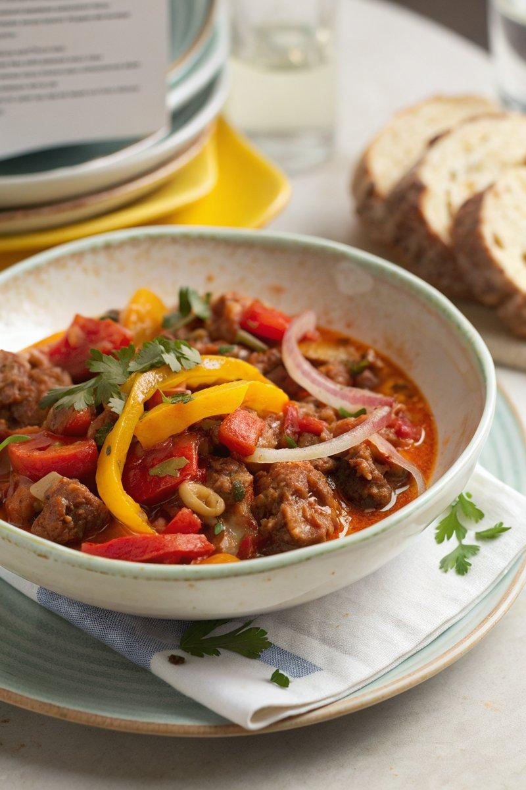

INGREDIENTS  - {'group': 'Main', 'item': '30g anchovies in oil, drained'}  - {'group': 'Main', 'item': '1 tbsp capers, drained'}  - {'group': 'Main', 'item': '2 red peppers, deseeded and sliced'}  - {'group': 'Main', 'item': '1 yellow pepper, deseeded and sliced'}  - {'group': 'Main', 'item': '1 large onion, chopped'}  - {'group': 'Main', 'item': '2 garlic cloves, chopped'}  - {'group': 'Seasoning', 'item': '1 tsp garlic granules'}  - {'group': 'Seasoning', 'item': '1 tsp onion powder'}  - {'group': 'Seasoning', 'item': '1 heaped tsp smoked paprika'}  - {'group': 'Seasoning', 'item': '1 tsp dried oregano'}  - {'group': 'Seasoning', 'item': '1 bay leaf'}  - {'group': 'Main', 'item': '400g can of plum tomatoes'}  - {'group': 'Main', 'item': 'olive oil, for drizzling'}  - {'group': 'Main', 'item': '1 cooking chorizo, halved'}  - {'group': 'Main', 'item': '1-2 tbsp red wine vinegar'}  - {'group': 'Main', 'item': '400 ml chicken stock'}  - {'group': 'Seasoning', 'item': 'salt and black pepper'} | PREP  Preheat the oven to 200°C (180°C (350°F (175°C)) fan). Deseed and slice the peppers, chop the onion and garlic, and halve the chorizo.  COOK  Place anchovies, capers, peppers, onion, garlic, garlic granules, onion powder, smoked paprika, oregano, bay leaf, and plum tomatoes in an ovenproof slow-cooker bowl. Season with salt and pepper, drizzle with olive oil, and roast for 20 mins until the vegetables begin to char. Meanwhile, heat a dry frying pan over high heat and fry the chorizo halves until blackened and their oil is released. Transfer the roasted vegetables to the slow-cooker, add the chorizo, red wine vinegar, and chicken stock. Cover and cook on high for 2 hrs or on low for 4 hrs.  PLATING  Serve the stew warm, either on its own with crusty bread or as a sauce over pasta.

NOTES:
For a deeper flavour, rub pork chops with the same seasoning and pan-roast them to serve alongside the stew.

